Terms of Reference

The Arab Republic of Egypt
Kafr ElSheikh Water and Sanitation Company

Kitchener Drain Project - Wastewater Component

Selection of Consultants

Terms of Reference

for

Consulting Services and Construction Supervision for the Kitchener Drain Projects for Kafr ElSheikh Water Supply and Sanitation Company

Ref. No./ Contract No. | 1/KAS/KP/Con/2022
Implementing Entity | Kafr El Sheikh Water Supply and Sanitation Company
Loan Operation No. | Nο FI 87454 Serapis Nο 2017/0090
Issue Date | April 2023

List of Abbreviations
ADB | Asian Development Bank
Consultant | Detailed Design Consultant (The Consultant)
DLP | Defects Liability Period
DEIA | Detailed Environmental Impact Assessment
EBRD | European Bank for Reconstruction and Development
EEAA | Egyptian Environmental Affairs Agency
EIB | European Investment Bank
E&S | Environmental and Social
ESCMP | Environmental Social Construction Management Plan
ESIA | Environmental and Social Impact Assessment
EU | European Union
EUR / € | Euro
FIDIC | International Federation of Consulting Engineers
GIS | Geographical Information System
H&S | Health and Safety
HCWW | Holding Company for Water & Wastewater
HSMP | Health and Safety Management Plan
ICB | International Competitive Bidding
IFC | International Finance Corporation
IFI | International Financial Institutions
ISSIP | Integrated Sanitation and Sewerage Infrastructure Project
IWSP I | Improved Water and Wastewater Programme – Phase I
IWSP II | Improved Water and Wastewater Programme – Phase II
Kafr ElSheikh WSC | Kafr El Sheikh Water Supply and Sanitation Company
KE | Key Expert
MHUUC | Ministry of Housing, Utilities and Urban Communities
NIP | Neighbourhood Investment Platform
NKE | Non-key Expert
NOPWASD | National Organization for Potable Water and Sanitary Drainage
NSRP | The National Rural Sanitation Programme
O&M | Operation and Maintenance
PIC | Project Implementation Consultant
PIU | Project Implementation Unit
PPMS | Project Performance Management System
RB / Red Book | FIDIC Conditions of Contract 1999 For Building and Engineering Works designed by the Employer
SRSSP | Sustainable Rural Sanitation Services Program
TEC | Technical Evaluation Committee
TOR | Terms of Reference
TSPA | Travel Safe Plan of Action
WSC | Water and Sanitation Company
WSRP | Water Sector Reform Programme
WSRP-II | Water Sector Reform Programme – Phase II
WWTP | Wastewater Treatment Plant
YB / Yellow Book | FIDIC Conditions of Contract 1999 For Electrical & Mech. Plant & For Building & Engineering Works Designed by the Contractor

Terms of Reference (TOR)
Consulting Services and Construction Supervision for the Construction of Al Nasryiah WWTP, Rehabilitation and Extension of Kafr Al Jarydah WWTP, Rehabilitation of Biyala and Ibshan WWTP, Construction of sewerage system in Kafr Al Jaraydah and Al Nasryyah Clusters of Kitchener Drain Projects in Kafr El Sheikh Governorate, implemented by Kafr El Sheikh Water Supply and Sanitation Company (Kafr El Sheikh WSC)

Implementing Entity
The Implementing Entity for this assignment is Kafr El Sheikh Water Supply and Sanitation Company (Kafr El Sheikh WSC)

Relevant Country Background
General Background
Egypt’s population is increasing by about 2 million individuals per year and stood at 96.3 million in 2018. The rapid increase in population is straining the country's infrastructure endowment and public service delivery.
Egypt is an arid country covering an area of approximately 1 million km2. It is also the most populous country in the Middle East / North Africa (MENA) with 55% of the total population living in rural areas. In addition, the vast majority of the country’s residents live on the narrow strip of arable land along the Nile Valley. Therefore, rapid population growth results in higher population density in both urban and rural environments as well as competition for water resources that are becoming scarcer. Moreover, high population density, population growth and inadequate solid waste services and infrastructure lead to significant pollution through solid wastes both in urban and rural contexts.

Background on Project

Description of the Kitchener Drain Project Scope
The Kitchener Drain project is the first phase of a larger investment programme aiming at the integrated depollution of the Kitchener Drain through three investment Components in:
- wastewater and sanitation,
- solid waste, and
- drain infrastructure rehabilitation.
A pre-feasibility study, funded by the EU and executed under the supervision of the EU Mediterranean Hot Spots Investment Programme (MeHSIP II), was undertaken in 2017 to prepare the project. The pre-feasibility study intended to increase sanitation coverage in the rural areas of the Kitchener Drain catchment by 25.4% (either through connection to a centralised sewage network or by providing improved on-site sanitation facilities) and provide an additional 122,000 m3/d of wastewater treatment capacity along with the rehabilitation of up to 5 existing WWTPs in the catchment area. In addition, the project would provide solid waste facilities (in the form of a collection system, transfer stations, separation facilities and sanitary landfills) for 4,800 tonnes/day of solid waste from both urban and rural areas of the catchment area. Finally, the Kitchener Drain itself and its subsidiary drains would be restored by removing accumulated waste and debris and rehabilitating auxiliary facilities such as pumping stations and bridges.
The first phase, comprising the most urgent investments, will be co-financed by the EU (grant from the NIP), EIB and EBRD. EIB financing will focus on the wastewater and sanitation project components and EBRD financing will focus on the solid waste and drain rehabilitation project components. Correspondingly, EIB will act as Lead Finance Institution in respect to the portion of the EU NIP Grant dedicated to wastewater and sanitation while EBRD will act as Lead Finance Institution in respect to the portion of the EU NIP Grant dedicated to solid waste and drain rehabilitation.
The overall objectives of the project are to support the depollution of the Kitchener Drain and the Mediterranean Sea as well as to improve the health and environmental situation of the people living in the project’s catchment area.

Project Stakeholders

The key Egyptian stakeholders for Component 1 of the project (and therefore the key counterparts under this assignment) are:

Ministry of Housing, Utilities and Urban Communities (MHUUC)

The MHUUC is responsible for the provision of water supply and sanitation services to the municipal and industrial subsectors. Under the MHUUC (i) the National Organization for Potable Water and Sanitary Drainage (NOPWASD), (ii) Construction Authority for Potable Water and Wastewater (CAPW), (iii) New Urban Communities Authority (NUCA), and (iv) the Egyptian Water and Wastewater Regulatory Agency (EWRA) along with their respective affiliated agencies, are responsible for planning, design, construction supervision, operation and maintenance of the municipal drinking water treatment plants, water supply distribution systems, sewage collection systems, and municipal WWTPs.

A Program Management Unit (PMU) has been established in the office of the MHUUC with a mandate to take the National Rural Sanitation Program forward while reporting directly to the Office of the Minister.

Holding Company for Water and Wastewater (HCWW)

In 2004, the HCWW was created under the public business sector and the remit of the Minister of Housing, Utilities and Urban Communities as the Government embarked on a reform of the wastewater sector in the country. A key element of this reform was the issuance of Presidential Decree 135, establishing HCWW and transforming the 14 largest water and wastewater utilities into its subsidiaries. HCWW has since then added and/or created an additional 11 utilities under its umbrella, resulting in 25 companies directly reporting to it. HCWW at the parent level is responsible for managing the operational, administrative, financial and commercial performance of its water / wastewater subsidiaries.
The Kafr El Sheikh Water Supply and Sanitation Company
Kafr El Sheikh Water Supply and Sanitation Company (Kafr ElSheikh WSC), one of HCWW’s affiliated companies, serves the population of the Kafr El Sheikh Governorate (total of around 3.4 million inhabitants) in the northern Nile Delta. The total length of the potable water network operated by Kafr ElSheikh WSC is 6,686 km. In total, the company operates 64 water treatment plants and 31 WWTPs. KESWWC is also one of the final beneficiaries of the ISSIP 1 project as well as the main beneficiary of the Kafr ElSheikh Wastewater Expansion (KSWWE) project. The company’s equity capital is EGP 1.9 billion (EUR 94.2 million). It currently employs 3,925 staff.

Project Implementation Consultant (PIC)

The PIC has been employed by the EIB to support the MHUUC, HCWW and Kafr ElSheikh WSC for the completion of Component 1 of the Kitchener Drain Project.

The mandate for the PIC is multi-fold and includes supporting the MHUUC/HCWW and the implementing entities in the following:

- Planning and managing the completion of Component 1 of the Kitchener Drain Project,
- Preparing the ground for a successful transition into the operation phase, and
- Creating capacities among their personnel for managing sanitation projects.

The PIC will support the MHUUC/HCWW and the implementing entities in ensuring that the Consultant perform their quality control and supervisory role effectively so that the Works Contracts are implemented in accordance with the requirements of the specifications and performance criteria.

The PIC will support the MHUUC/HCWW and implementing entities in establishing a monitoring system with the Consultant to facilitate regular feedback on the Contractors’ compliance with the specifications. Audit and review of environmental, social and health and safety performance of Contractors and construction works will be an integral aspect of this task.

The PIC will support the implementing entities in administering all the contracts (both Service and Works contracts), which will involve inter alia the following:

- Monitoring the progress of all the contracts under the project, identifying reasons for any delays and recommending mitigating measures.
- Receiving and resolving any queries raised regarding design issues or changes that may need to be made.
- Considering variation orders requests and coordinating with the implementing entities and the EIB and issuing variation orders once agreed.
- Monitoring the budget and cash flow of all the contracts.
- Planning and implementing monthly site reports from the Consultant.
- High-level contract management using the advice and expertise from the Consultant, in particular making timely decisions on variations and claims and handling and resolving any claims submitted to the Consultant from the Contractors.
- Approving and processing payments to Consultant and Contractors and suppliers.
- Implementing the payment procedures and processing the payments to the Consultant and Contractors.
- Obtaining permits expeditiously.
- Review a monthly programme monitoring system prepared by the Consultant included:
  - Identify actual progress against planned progress,
  - Identify issues and / or reasons causing any delays,
  - Flag any issue that may have a cost impact,
  - Monitor and manage environmental, social and health and safety risks, and
  - Discuss the environmental mitigating measures proposed by the Consultant and to be implemented by the Contractor.

Objectives of the Assignment
The Kafr ElSheikh WSC wishes to engage the services of one Consulting firm to perform the role of the Detailed Design Consultant (Consultant), including the role of construction supervision Engineer.
The Consultant will be contracted to the Kafr ElSheikh WSC but will liaise extensively with the PIC in order for the PIC to fulfil their duties as described above.
The objective of the Consultant assignment is to provide consulting services to achieve the following two packages: -
4.1 Package One
- Al-Nasryyah WWTP:
The works includes the construction of a new treatment plant for Al-Nasryyah cluster with a design capacity of 10,000 m3/d for target year 2037 extendable to 15,000 m3/d for target year 2057. The Consultant will provide the design review of Contractor’s submission and the supervision of the construction of works. The contract with the Contractor shall be under the FIDIC Conditions of Contract Yellow Book 1999 “FIDIC Conditions of Contract for Plant & Design-Build (1999) for Electrical & Mech. Plant & For Building & Engineering Works Designed by the Contractor”.
- Kafr Al Jaraydah WWTP:
The works includes the rehabilitation of the existing plant with a design capacity of 2,100 m3/d and the construction of an extension treatment plant with an additional design capacity of 5,000 m3/d for target year 2037 extendable to 7,500 m3/d for target year 2057 (Additional 2,500 m3/d).The Consultant will provide a detailed list for the rehabilitation works, review and assess the Contractor’s offered quotation for the rehabilitation works then supervise the needed administrative preparations for contracting the rehabilitation works, and the design review of the Contractor’s submission and the supervision of the construction of the extension works. The contract with the Contractor shall be under the FIDIC Conditions of Contract Yellow Book 1999 “FIDIC Conditions of Contract for Plant & Design-Build (1999) for Electrical & Mech. Plant & For Building & Engineering Works Designed by the Contractor”.
4.2 Package Two
- Biyala WWTP:
The works includes the rehabilitation of the existing plant with a design capacity of 20,000 m3/d. The Consultant will provide the detailed design and supervision of rehabilitation works. The contract with the Contractor shall be under the FIDIC Conditions of Contract Red Book 1999 “FIDIC Conditions of Contract for Construction (1999) for Building and Engineering Works designed by the Employer”
- Ibshan WWTP:
The works includes the rehabilitation of the existing plant with a design capacity of 2,400 m3/d. The Consultant will provide the detailed design and supervision of rehabilitation works. The contract with the Contractor shall be under the FIDIC Conditions of Contract Red Book 1999 “FIDIC Conditions of Contract for Construction (1999) for Building and Engineering Works designed by the Employer”.
- Al-Nasryyah Cluster:
The Consultant shall be responsible for the detailed design and preparation of tender documents of the sewerage system of Al-Nasryyah Cluster which include four (4) villages and satellites to be served by centralized or decentralized system, supervision of construction works. The contract with the Contractor shall be under the FIDIC Conditions of Contract Red Book 1999 “FIDIC Conditions of Contract for Construction (1999) for Building and Engineering Works designed by the Employer”.
- Kafr Al Jaraydah Cluster:
The Consultant shall be responsible for the detailed design and preparation of tender documents of the sewerage system of Kafr Al Jaraydah Cluster which include four (4) villages and satellites to be served by centralized or decentralized system, and the supervision of construction works. The contract with the Contractor shall be under the FIDIC Conditions of Contract Red Book 1999 “FIDIC Conditions of Contract for Construction (1999) for Building and Engineering Works designed by the Employer”.

4.3 Background for Al-Nasryyah WWTP
- Al-Nasryyah WWTP is a new WWTP to serve Al-Nasryyah cluster including (4) four villages and two (2) satellites to be served by centralized or decentralized system in addition to two villages (Al Himmah and Iz. Badawi). The design of the sewerage system of the two additional villages (Al Himmah and Iz. Badawi) and their force main to the Al_Nasryyah WWTP are outside the Consultant scope of works. The location of the new treatment plant is indicated in Figure 1 and Figure 2.
- The PIC shall issue the Works Contract tender documents for the construction works for the Al-Nasryyah WWTP based on FIDIC Conditions of Contract Yellow Book 1999 “FIDIC Conditions of Contract for Plant & Design-Build (1999), For Electrical & Mech. Plant & For Building & Engineering Works Designed by the Contractor”. (The PIC shall provide Al-Nasryyah WWTP outline design for this purpose).
- The Consultant shall review the tender documents issued by PIC, conduct and support Kafr ElSheikh WSC during the technical and financial evaluation of the bids received, awarding process.
- Performing the role of the Engineer, the Consultant shall review and approve the detailed design submitted by the Contractor, and supervise the construction, operation and maintenance of the plant and support the Kafr ElSheikh WSC during the handover procedure from the Contractor.
- The Consultant shall support Kafr ElSheikh WSC during the operation and maintenance year and the training period for one year
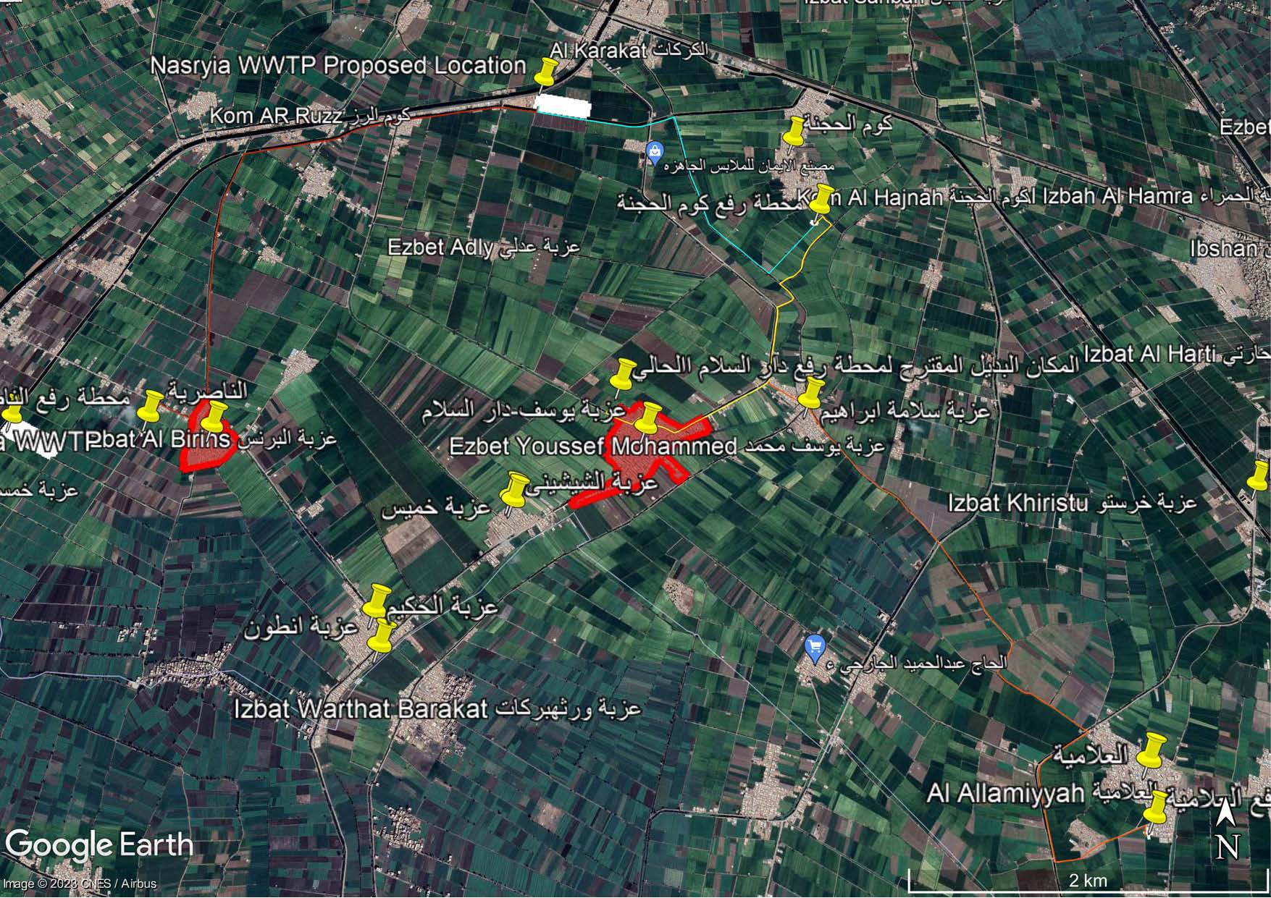
Figure 1: Proposed location of Al-Nasryyah WWTP

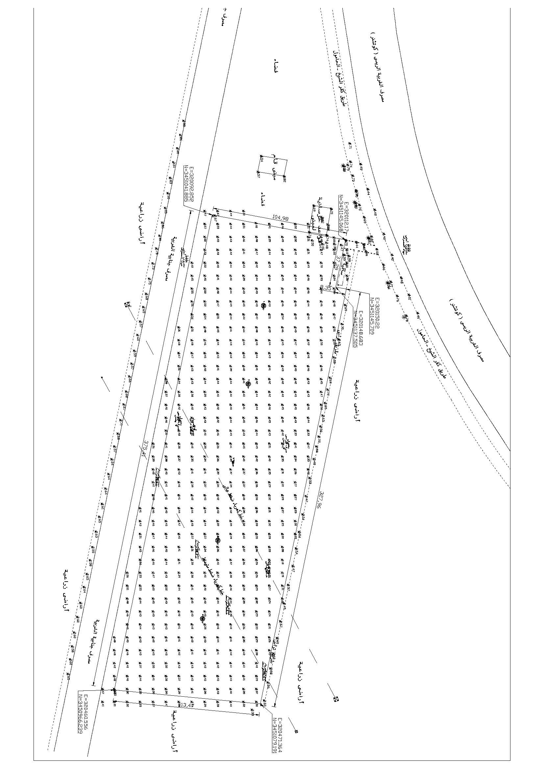
Figure 2: Proposed Location and Dimension of Al-Nasryyah WWTP

4.4 Background for Kafr Al Jaraydah WWTP:
4.4.1 Rehabilitation Works
- The Kafr Al Jaraydah WWTP is in poor condition with the working load above capacity and not meeting the environmental requirements. Kafr Al Jaraydah WWTP consists of oxidation ditch treatment process with design capacity of 2,100 m3/d.
- To bring the WWTP back to optimum operating conditions the WWTP needs to be rehabilitated which will involve structural, mechanical and electrical rehabilitation works and need extension of treatment capacity.
- Kafr Al Jaraydah WWTP consisted of the main following units
  - (1) Main inlet reception tank
  - (2) Mechanical Bar Screen
  - (1) Grit removal with two channels
  - (2) Aeration tank (oxidation ditch) with 4 brush aerators
  - (1) Secondary settling circular Tank
  - (2) Sludge Thickeners
  - (1) Chlorine contact tank
  - (1) Chlorination system
  - Recycle activated sludge pump station
  - Waste Activated Sludge (excess Sludge) pump station
  - (10) Sludge drying beds
- The PIC will issue the tender documents of Kafr Al Jarydah extension works including a provisional sum for the rehabilitation works. The tender documents will include the preliminary required rehabilitation works and the status assessment report as provided by Kafr ElSheikh WSC and reviewed by PIC.
- The Consultant shall review the status assessment report issued by Kafr ElSheikh WSC, conduct technical assessment and evaluate the technical status and performance of all civil and electromechanical components of the plant, conduct a detailed assessment of the plant, specify all rehabilitation works needed for the plant, prepare the detailed list of rehabilitation works. This might be before or after the start of Kafr Al Jarydah Works Contract.
- Request a price quotation from the Contractor to conduct the detailed list of rehabilitation works and propose any necessary works for the good performance of the rehabilitated part of Kafr Al Jaraydah WWTP.
- Review the Contractor quotation and seek the approval of the Kafr ElSheikh WSC and the PIC for the total amount shall not exceed the provisional sum amount.
- Performing the role of the Engineer as in FIDIC Conditions of Contract Yellow Book 1999 “FIDIC Conditions of Contract for Plant & Design-Build (1999) for Electrical & Mech. Plant & For Building & Engineering Works Designed by the Contractor. , the Consultant shall review and approve the works methodology and workshop drawings submitted by the Contractor, and supervise the rehabilitation works, operation and maintenance of the plant and support the Kafr ElSheikh WSC during the handover procedure from the Contractor.
- The Consultant shall support Kafr ElSheikh WSC during the operation and maintenance year and the training period for one year.
- The location of Kafr Al Jaraydah WWTP is indicated in Figure 3 and Figure 4

4.4.2 Kafr Al Jaraydah WWTP Extension Works
- The PIC shall issue the Works Contract tender documents for the construction works for the Kafr Al Jaraydah WWTP extension based on FIDIC Conditions of Contract Yellow Book 1999 “FIDIC Conditions of Contract for Plant & Design-Build (1999), For Electrical & Mech. Plant & For Building & Engineering Works Designed by the Contractor”. (The PIC shall provide Kafr Al Jaraydah WWTP outline design for this purpose).
- The Consultant shall review the tender documents issued by PIC, conduct and support Kafr ElSheikh WSC during the technical and financial evaluation of the bids received, awarding process.
- Performing the role of the Engineer, the Consultant shall review and approve the detailed design submitted by the Contractor, and supervise the construction, operation and maintenance of the plant and support the WSC during the handover procedure from the Contractor.
- The Consultant shall support Kafr ElSheikh WSC during the operation and maintenance year and the training period for one year
- The location of Kafr Al Jaraydah WWTP is indicated in Figure 3 and Figure 4
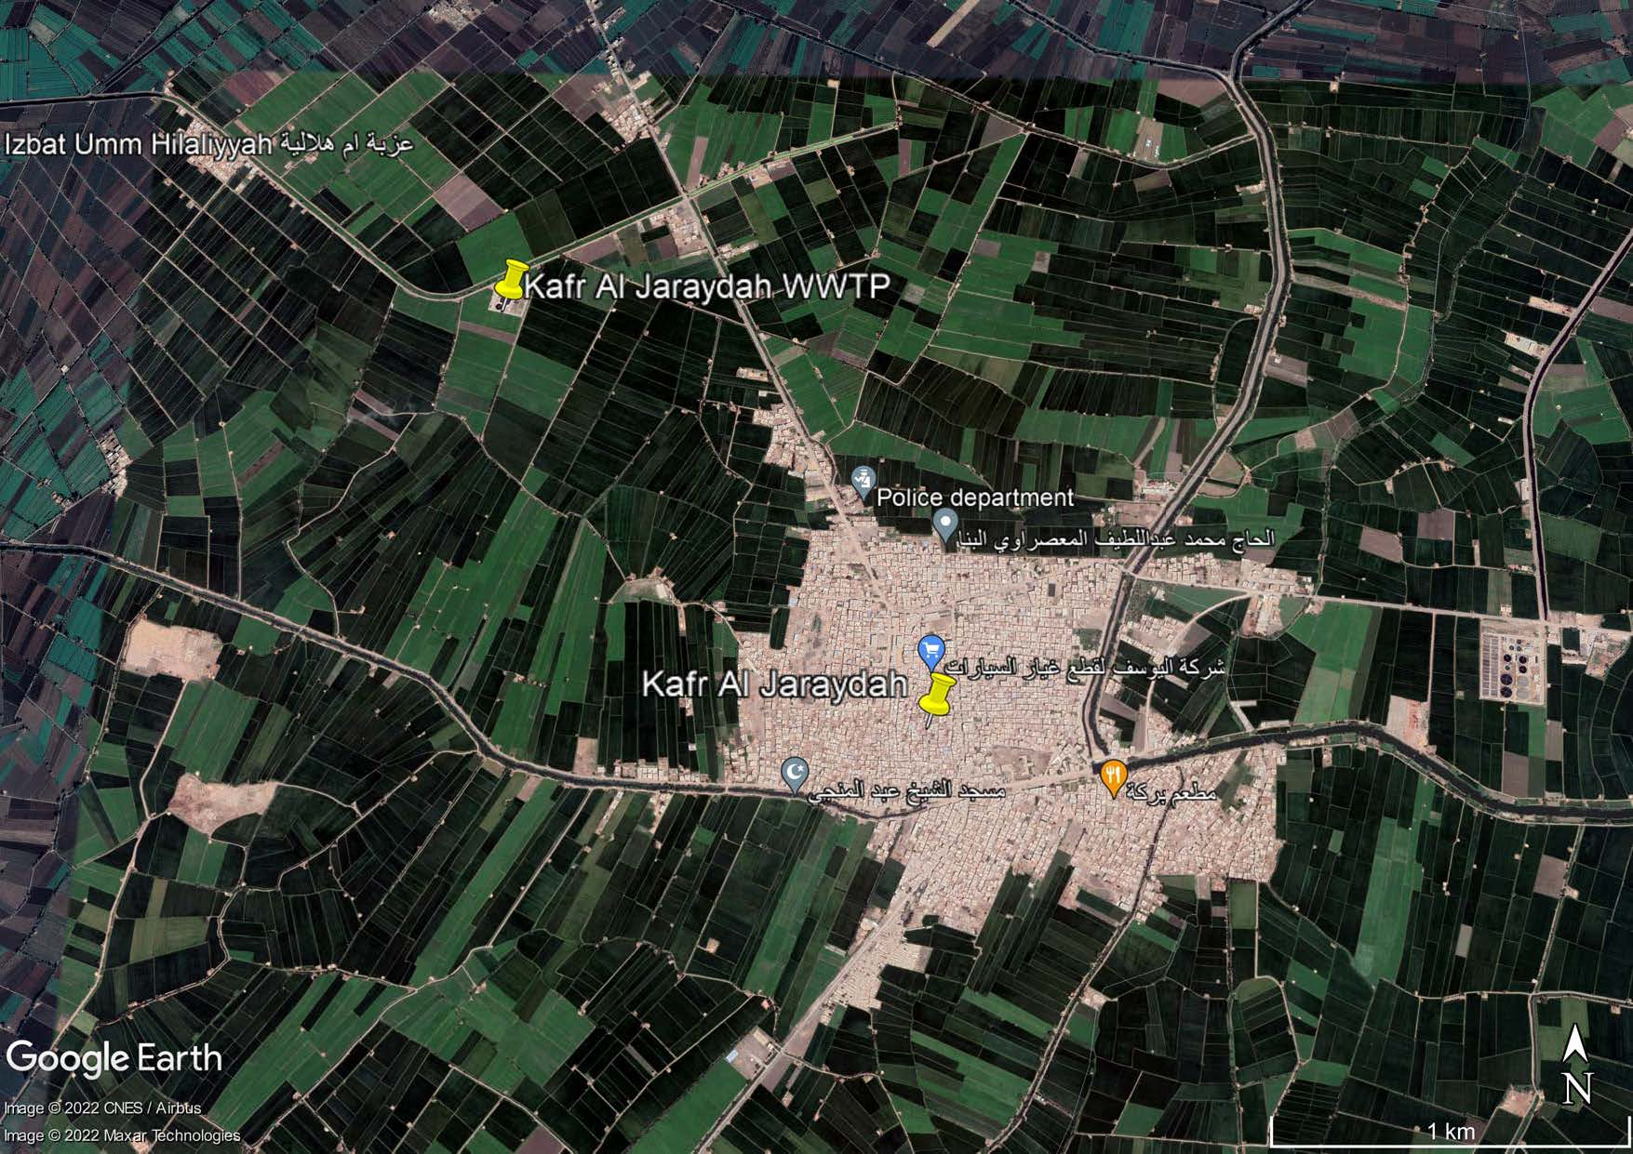
Figure 3: Location of Kafr Al Jaraydah WWTP

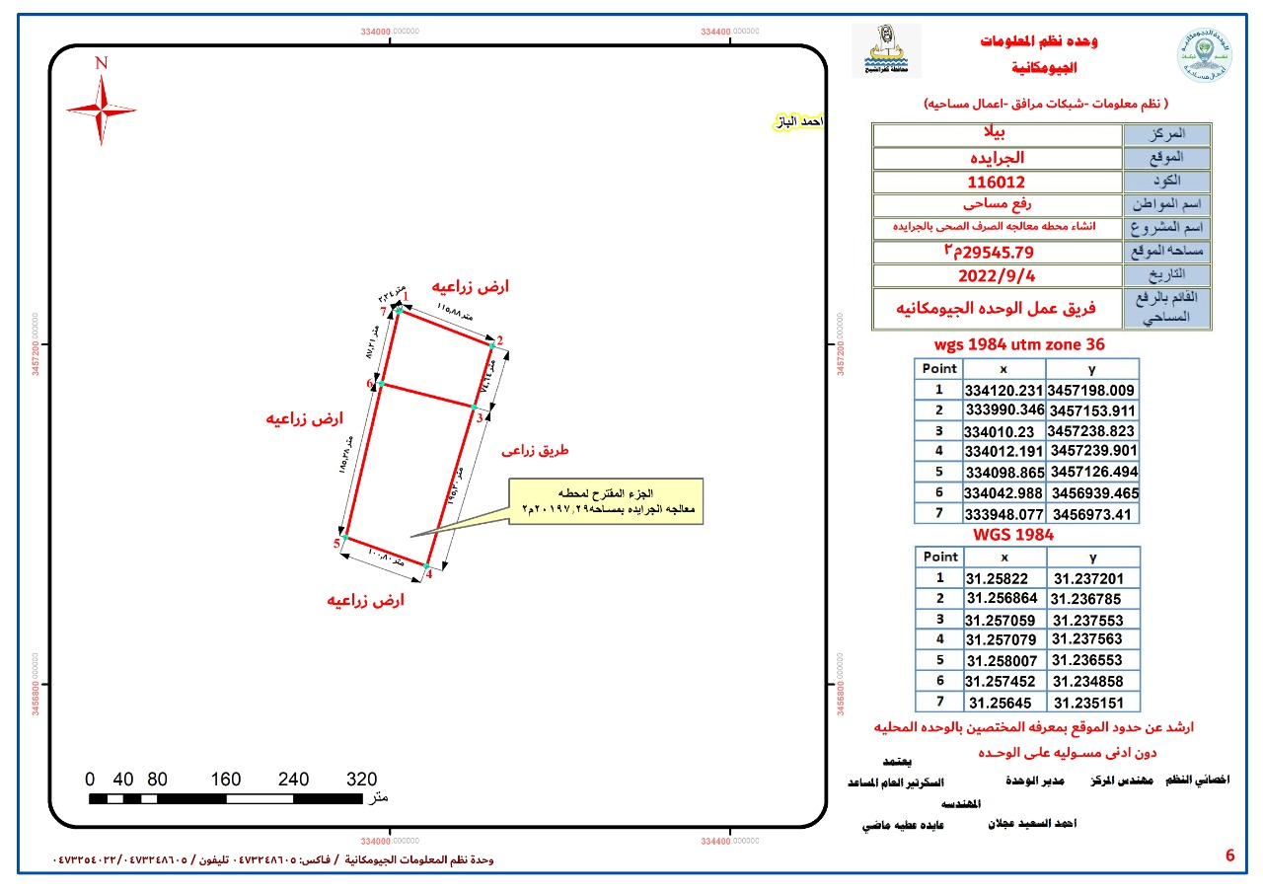
Figure 4: Proposed Location and Dimension of Kafr Al Jaraydah WWTP Extension

4.5 Background for Biyala WWTP:
- The Biyala WWTP is in a fair condition with the working load above capacity. Biyala WWTP consists of conventional activated sludge process with design capacity of 20,000 m3/d.
- To bring the WWTP back to optimum operating conditions the WWTP needs to be rehabilitated which will involve structural, mechanical and electrical rehabilitation works.
- Biyala WWTP consisted of the main following units
  - (1) Main inlet reception tank
  - (3) Mechanical Bar Screen
  - (1) Manual screen
  - (4) Aerated Grit removal tanks
  - (4) Circular primary sedimentation tanks
  - (4) Aeration tank (conventional activated sludge tanks) with mechanical surface aerators
  - (4) Secondary settling circular Tank
  - (2) Sludge Thickeners
  - (1) Chlorine contact tank
  - (1) Chlorination system
  - (4) Recycle activated sludge screw pumps
  - (4) Waste Activated Sludge (excess Sludge) submersible pump station
  - (3) Thickened sludge pumps
  - (48) Sludge drying beds
- The Consultant shall review the status assessment report issued by PIC, conduct technical site visits to assess and evaluate the technical status and performance of all civil and electromechanical components of the plant (this might entail temporary draw down of levels in the plant to survey the concrete condition), conduct a detailed assessment of the plant, specify all rehabilitation works needed for the plant, prepare the rehabilitation works design report, issue the tender documents (10 hard copies and 3 CDs) for rehabilitation works using the FIDIC Conditions of Contract Red Book 1999 “FIDIC Conditions of Contract for Construction (1999) for Building and Engineering Works designed by the Employer”, evaluate and support Kafr ElSheikh WSC in the technical and financial evaluation of the bids received, assist in the awarding process.
- Performing the role of the Engineer, the Consultant shall review and approve the works methodology submitted and workshop drawings submitted by the Contractor, and supervise the rehabilitation works, operation and maintenance of the plant and support the Kafr ElSheikh WSC during the handover procedure from the Contractor.
- The Consultant shall support Kafr ElSheikh WSC during the operation and maintenance year and the training period for one year.
- The location of Biyala WWTP is indicated in Figure 5
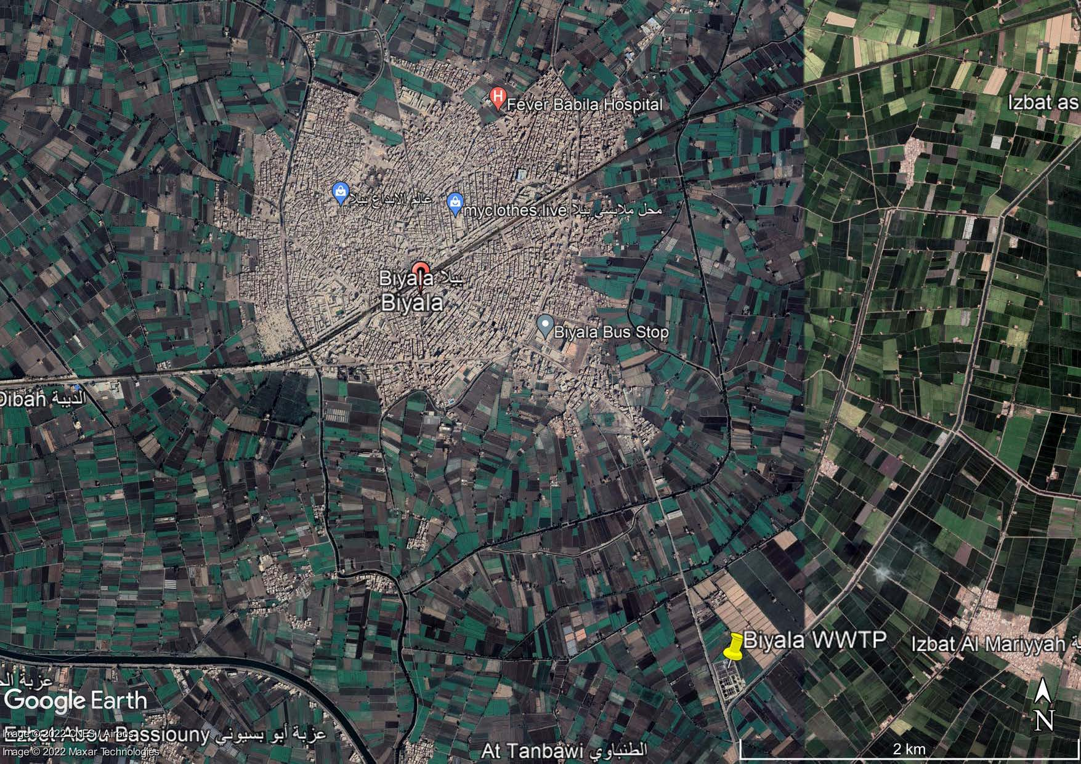Figure 5: The location of Biyala WWTP

4.6 Background for Ibshan WWTP:
- The Ibshan WWTP is in a poor condition with the working load above capacity. Ibshan WWTP consists of oxidation ditch treatment process with a design capacity of 2,400 m3/d.
- To bring the WWTP back to optimum operating conditions the WWTP needs to be rehabilitated which will involve structural, mechanical, and electrical rehabilitation works.
- Ibshan WWTP consisted of the main following units
  - (1) Main inlet reception tank
  - (2) Mechanical Bar Screen
  - (1) Grit removal with two channels
  - (2) Aeration tank (oxidation ditch) with 4 brush aerators
  - (1) Secondary settling circular Tank
  - (2) Sludge Thickeners
  - (1) Chlorine contact tank
  - (1) Chlorination system
  - (3) Recycle activated sludge submersible pumps
  - (2) Waste Activated Sludge (excess Sludge) submersible pumps
  - (10) Sludge drying beds
- The Consultant shall review the status assessment report issued by PIC, conduct technical site visits to assess and evaluate the technical status and performance of all civil and electromechanical components of the plant (this might entail temporary draw down of levels in the plant to survey the concrete condition), conduct a detailed assessment of the plant, specify all rehabilitation works needed for the plant, prepare the rehabilitation works design report, issue the tender documents (10 hard copies and 3 CDs) for rehabilitation works using the FIDIC Conditions of Contract Red Book 1999 “FIDIC Conditions of Contract for Construction (1999) for Building and Engineering Works designed by the Employer”, support Kafr ElSheikh WSC in the technical and financial evaluation of the bids received, assist in the awarding process.
- Performing the role of the Engineer, the Consultant shall review and approve the works methodology and workshop drawings submitted by the Contractor, and supervise the rehabilitation works, operation and maintenance of the plant and support the Kafr ElSheikh WSC during the handover procedure from the Contractor.
- The Consultant shall support Kafr ElSheikh WSC during the operation and maintenance year and the training period for one year.
- The wastewater flow from the cluster shall be directed to Al Nasryyah WWTP.
- The location of Ibshan WWTP is indicated in Figure 6

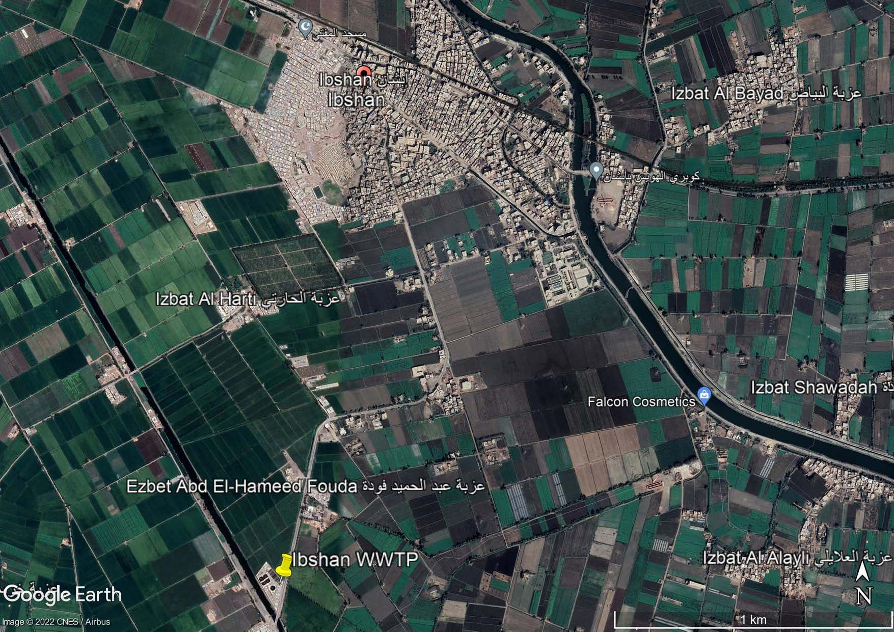
Figure 6: The location of Ibshan WWTP

4.7 Background for Al-Nasryyah Cluster
- Al-Nasryyah cluster includes (4) four mother villages (Al-Nasryyah – Ezbat Yousef [Dar Alsalam] – Al Allamiyyah – Kom Al Hajnah) and their satellites to be served by centralized or decentralized system.
- Al-Nasryyah cluster is located in Biyala district, Kafr ElSheikh governorate as indicated in Figure 1.
The estimated population for the cluster is indicated in Table 1.
Table 1 Al Nasryyah Cluster Predicted Population
Village | Population (Capita)
 | 2021 | 2037 | 2057
Al-Nasryyah | 2,160 | 3,308 | 4,916
Ezbat Yousef [Dar Alsalam] | 10,759 | 19,034 | 28,284
Al Allamiyyah | 2,386 | 2,798 | 3,414
Kom Al Hajnah | 2,488 | 2,917 | 3,559

4.8 Background for Kafr Al Jaraydah Cluster
- Kafr Al Jaraydah cluster includes (4) four mother villages (Iz. Rus Al Farkh, Iz.Al Ayqah, Al Shutut, and Siraywah Al Kubra) and their satellites to be served by centralized or decentralized system.
- Kafr Al Jaraydah cluster is located in Biyala district, Kafr ElSheikh governorate as indicated in Figure 7.
- The wastewater flow from the cluster shall be directed to Hazeq WWTP
The estimated population for the cluster is indicated in Table 2
Table 2 Kafr Al Jaraydah Cluster Predicted Population
Village | Population (Capita)
 | 2021 | 2037 | 2057
Iz. Rus Al Farkh | 9,475 | 16,303 | 24,225
Iz.Al Ayqah | 1,321 | 1,851 | 2,750
Al Shutut | 2,302 | 3,251 | 4,831
Siraywah Al Kubra | 4,066 | 5,525 | 8,210

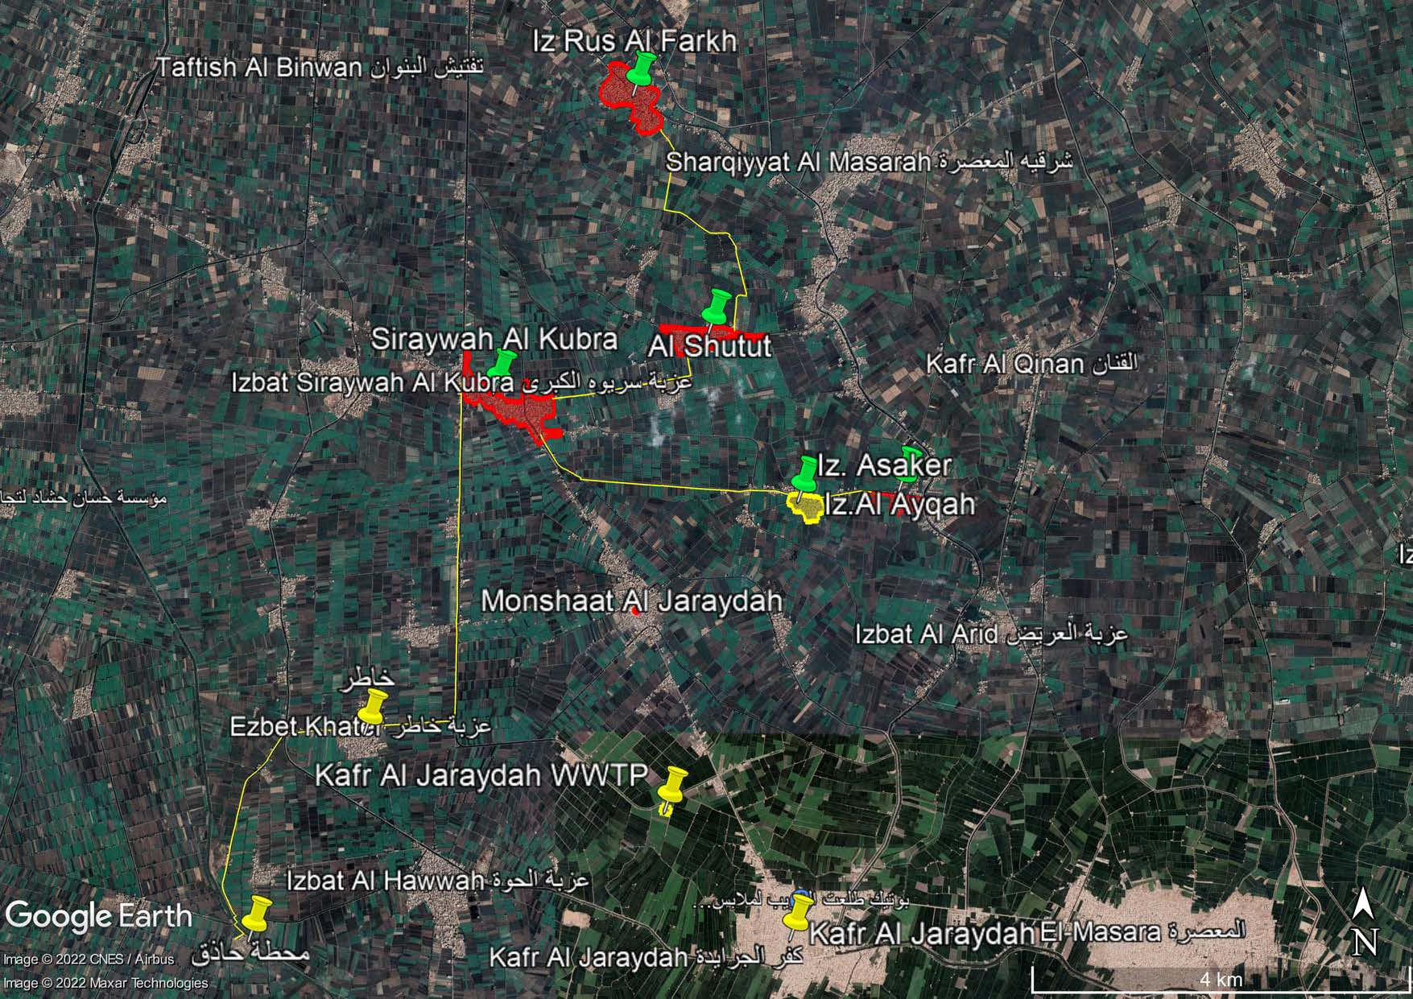
Figure 7 Location of Kafr Al Jaraydah Cluster

Scope of Work

Package One
5.1 Al-Nasryyah WWTP
- The consultant shall review all the tender documents issued by the PIC for the design and build treatment plant system, including all the functional designs of the treatment plant and equipment prepared by the Project Implementation Consultant (PIC) for Al-Nasryyah WWTP, and according to the standard model of the tender documents approved and in accordance with the guide of procurement procedures and contracts applied to the project.
- The Consultant shall provide technical assistance to Kafr ElSheikh WSC and prepare all necessary reports for approval from the Kafr ElSheikh WSC and PIC during all stages of bidding for the award of design and build contracts in accordance with the instructions of the "Procurement procedures and contracts manual" PPM. These include but not limited to participating in the opening of bids, organize the meeting with TEC and meeting with bidders and prepare the minutes of meeting, assisting the PIC in responding to all questions and inquiries of bidders or supply companies involved in tenders for the scope of its work, attending pre-bid meeting and prepare the minutes, conduct the technical and financial evaluation of the received bids, give the proper advise to the bidding evaluation committee, prepare all the required reports including the combined technical and financial evaluation report, support Kafr ElSheikh WSC in awarding procedure to the Contractor, in accordance with the EIB requirements as set out in the EIB Guide to Procurement, , as well as preparing the notification of awarding and draft of the contract agreement to the Contractor
- Following award of the Works Contract, the Consultant will review and seek approval from the PIC for the detailed design submitted by the Contractor.
- The Consultant shall perform the role of the Engineer in accordance with the FIDIC Conditions of Contract Yellow Book 1999 “FIDIC Conditions of Contract for Plant & Design-Build (1999), For Electrical & Mech. Plant & For Building & Engineering Works Designed by the Contractor”.
- The Consultant shall supervise the operation and maintenance of the plant, and during the defects liability period (DLP), and support the Kafr ElSheikh WSC during the handover procedure from the Contractor.
- The Consultant shall supervise the training carried out by the Contractor to Kafr ElSheikh WSC operation staff on the operation and maintenance of the Al Nasryyah treatment plant.

5.2 Kafr Al Jaraydah WWTP Rehabilitation and Extension
5.2.1 Kafr Al Jaraydah WWTP Extension Works
- The consultant shall review all the tender documents issued by the PIC for the design & build treatment plant system, including all the functional designs of treatment plant and equipment prepared by the Project Implementation Consultant (PIC) for Kafr Al Jaraydah WWTP extension works, and according to the standard model of the tender documents approved and in accordance with the guide of procurement procedures and contracts applied to the project.
- The Consultant shall support the PIC and Kafr ElSheikh WSC by clarifying the Contractors’ inquiries and during the technical and financial evaluation of the bids received.
- The Consultant shall provide technical assistance to Kafr ElSheikh WSC and prepare all necessary reports for approval from the Kafr ElSheikh WSC and PIC during all stages of bidding for the award of design and build contracts in accordance with the instructions of the "Procurement procedures and contracts manual" PPM. These include but not limited to participating in the opening of bids, organize the meeting with TEC and meeting with bidders and prepare the minutes of meeting, assisting the PIC in responding to all questions and inquiries of bidders or supply companies involved in tenders for the scope of its work, attending pre-bid meeting and prepare the minutes, conduct the technical and financial evaluation of the received bids, give the proper advise to the bidding evaluation committee, prepare all the required report including the combined technical and financial evaluation report, support Kafr ElSheikh WSC in awarding procedure to the Contractor, , in accordance with the EIB requirements as set out in the EIB Guide to Procurement, as well as preparing the notification of awarding and draft of the contract agreement to the Contractor
- Following award of the Works Contract, the Consultant will review and seek approval from the PIC for the detailed design submitted by the Contractor.
- The Consultant shall perform the role of the Engineer in accordance with the FIDIC Conditions of Contract Yellow Book 1999 “FIDIC Conditions of Contract for Plant & Design-Build (1999), For Electrical & Mech. Plant & For Building & Engineering Works Designed by the Contractor”.
- The Consultant shall supervise the operation and maintenance of the plant, and during the defects liability period (DLP), and support the Kafr ElSheikh WSC during the handover procedure from the Contractor.
- The Consultant shall supervise the training carried out by the Contractor to Kafr ElSheikh WSC operation staff on the operation and maintenance of the Kafr Al Jaraydah treatment plant.

5.2.2 Kafr Al Jaraydah WWTP Rehabilitation Works
- The PIC will issue the tender documents of Kafr Al Jaraydah extension works including a provisional sum for the rehabilitation works. The tender documents will include the preliminary required rehabilitation works and the status assessment report as provided by Kafr ElSheikh WSC and reviewed by PIC.
- The Consultant shall review the preliminary assessment report (prepared by the Kafr ElSheikh WSC) for the required rehabilitation works for the treatment plant for all civil and electromechanical works.
- The Consultant shall conduct technical assessment and evaluate the technical status of all civil and electromechanical works required for the rehabilitation works of the treatment plant and prepare the detailed list of the required rehabilitation works. This might be before or after the start of Kafr Al Jaraydah Works contract.
- The Consultant shall submit detailed list of rehabilitation works to the Kafr ElSheikh WSC and PIC for approval.
- Requesting from the Contractor a price quotation to conduct the detailed list of rehabilitation works and propose any necessary works for the good performance of the rehabilitated part of Kafr Al Jaraydah WWTP.
- Review the Contractor’s quotation and include the breakdown and price analysis of the rehabilitation works and seek the approval of the Kafr ElSheikh WSC and the PIC, the rehabilitation works shall not exceed the provisional sum amount allocated in the signed contract.
- Following the approval of the concerned parties, the Consultant will review and seek approval from the PIC for the workshop drawings submitted by the Contractor.
- The Consultant shall perform the role of the Engineer in accordance with the FIDIC Conditions of Contract Yellow Book 1999 “FIDIC Conditions of Contract for Plant & Design-Build (1999), For Electrical & Mech. Plant & For Building & Engineering Works Designed by the Contractor”.
- The Consultant shall supervise the operation and maintenance of the plant and during the defects liability period (DLP) and support the Kafr ElSheikh WSC during the handover procedure from the Contractor.
- The Consultant shall supervise the training carried out by the Contractor to Kafr ElSheikh WSC operation staff on the operation and maintenance of the treatment plant.
Package Two
5.3 Biyala and Ibshan WWTPs Rehabilitation
- The Consultant shall review the preliminary assessment report (prepared by the PIC) for the required rehabilitation works for the treatment plants for all civil and electromechanical works.
- The Consultant shall conduct several technical site visits with the purpose of evaluating and assessment the technical status of all civil and electromechanical works required for the rehabilitation works of the treatment plant.
- The Consultant shall submit the technical assessment report of the works required to the Kafr ElSheikh WSC and PIC for approval.
- The Consultant shall prepare the tender documents (based on the FIDIC Conditions of Contract Red Book 1999 “FIDIC Conditions of Contract for Construction (1999) for Building and Engineering Works designed by the Employer”) for the rehabilitation works. Submit 10 hard copies and 3 CDs of the approved tender documents to Kafr ElSheikh WSC
- The Consultant shall provide technical assistance to Kafr ElSheikh WSC and prepare all necessary reports for approval from the Kafr ElSheikh WSC and PIC during all stages of bidding for the award of design and build contracts in accordance with the instructions of the "Procurement procedures and contracts manual" PPM. These include but not limited to participating in the opening of bids, organize the meeting with TEC and meeting with bidders and prepare the minutes of meeting, responding to all questions and inquiries of bidders or supply companies involved in tenders for the scope of its work, attending pre-bid meeting and prepare the minutes, conduct the technical and financial evaluation of the received bids, give the proper advise to the bidding evaluation committee, prepare all the required report including the combined technical and financial evaluation report, support Kafr ElSheikh WSC in awarding procedure to the Contractor, , in accordance with the EIB requirements as set out in the EIB Guide to Procurement, as well as preparing the notification of awarding and draft of the contract agreement to the Contractor.
- Following award of the Works Contract, the Consultant will review and seek approval from the PIC for the workshop drawings submitted by the Contractor
- The Consultant shall perform the role of the Engineer in accordance with FIDIC Conditions of Contract Red Book 1999 “FIDIC Conditions of Contract for Construction (1999) for Building and Engineering Works designed by the Employer”
- The Consultant shall supervise the operation and maintenance of the plant and during the defects liability period (DLP) and support the Kafr ElSheikh WSC during the handover procedure from the Contractor.
- The Consultant shall supervise the training carried out by the Contractor to Kafr ElSheikh WSC operation staff on the operation and maintenance of the Biyala and Ibshan treatment plants.

5.4 Al-Nasryyah and Kafr Al Jaraydah Cluster Sewerage System
The Consultant scope of works includes two clusters. Al-Nasryyah cluster which includes four (4) villages (Al-Nasryyah – Ezbat Yousef [Dar Alsalam] – Al Allamiyyah – Kom Al Hajnah) and their satellites according to the criteria of choosing the satellite to be served by centralized or decentralized system. Kafr Al Jaraydah cluster which includes (4) four villages (Iz. Rus Al Farkh, Iz.Al Ayqah, Al Shutut, and Siraywah Al Kubra) and their satellites according to the criteria of choosing the satellite to be served by centralized or decentralized system. The scope of work within these clusters includes the following consultancy services:
- Topographical survey of the full and detailed areas of Al-Nasryyah and Kafr Al Jaraydah clusters including the location of the pump stations and the route of the force mains, as indicated in Figure 1 and Figure 7 respectively
- Preparing the necessary geotechnical investigation for networks, force mains, pumping stations and treatment plants (if any) and preparing the technical report on soil and foundations by a specialized consultant in accordance with the requirements of the Egyptian code in terms of the numbers and depths of the boreholes and identify all the required foundation recommendations as well as the work of ground water dewatering required during construction of all cluster’s villages and satellites to be served by centralized system.
- The preparation of the final detailed designs and the final design report taking into account the concept design prepared by the Project Implementation Consultant (PIC). The Consultant output under this item shall include:
  - Prepare detailed designs and drawings for gravity networks, force mains, pump stations and prepare the final design report for the villages including satellites that will be serviced in a centralized or decentralized system (on site sanitation).
  - Prepare tender documents for cluster sewerage system including sewerage system, pump stations, and force mains up to the treatment plant.
- Prepare the estimated cost of each contract in the form of a priced bill of quantities after coordination and review with the PIC and place it inside a separate closed envelope to be handed over to the Kafr El Sheikh WSC.
- Support the Kafr ElSheikh WSC in the work of tendering and awarding to the Contractors. These include but not limited to participating in the opening of bids, organize the meeting with TEC and meeting with bidders and prepare the minutes of meeting, responding to all questions and inquiries of bidders or supply companies involved in tenders for the scope of its work, attending pre-bid meeting and prepare the minutes, conduct the technical and financial evaluation of the received bids, give the proper advise to the bidding evaluation committee, prepare all the required report including the combined technical and financial evaluation report, support Kafr ElSheikh WSC in awarding procedure to the Contractor, in accordance with the EIB requirements as set out in the EIB Guide to Procurement as well as preparing the notification of awarding and draft of the contract agreement to the Contractor.
- Supervising the implementation of the works, which include supervising the implementation of the necessary work of gravity networks, force mains, pump stations, including satellites to be served in a centralized or decentralized system (on site sanitation).
- Coordinating with the construction supervision consultant for the construction of sewerage system and force mains for Al Himmah and Iz. Badawi villages to be connected to Al Nasryyah WWTP on a timely manner.
- Supervising the training of Kafr ElSheikh WSC staff and providing full support in accordance with the requirements of the terms of reference of works during defects liability period.
- The Consultant shall perform the role of the Engineer in accordance with the FIDIC Conditions of Contract Red Book 1999 “FIDIC Conditions of Contract for Construction (1999) for Building and Engineering Works designed by the Employer.”

Consultant Duties and Methodology
In addition to the general requirements above the tasks of the consultant shall comprise the following common duties related to the project components described above
- Design review of Contractor’s design submission in accordance with the FIDIC yellow book for Al Nasryyah WWTP and Kafr Al Jaraydah WWTP extension and rehabilitation works..
- Issue an administrative order for Kafr Al Jaraydah WWTP rehabilitation works which shall not exceed the provisional sum amount as estimated by PIC in tender documents.
- Preliminary Design Phase for Biyala, and Ibshan WWTPs rehabilitation works (including life cost comparison of alternative process option), as well as Al Nasryyah and Kafr Al Jarydah clusters sewerage system.
- Preparation of detailed design of rehabilitation works and Tender Documents for Biyala, and Ibshan WWTPs, as well as Al Nasryyah and Kafr Al Jarydah clusters sewerage system.
- Assistance to the PIU in obtaining Environmental Approvals for all WWTPs and sewerage systems.
- Assistance to the PIU for tendering and contracting for all WWTPs including Al-Nasryyah, Kafr Al Jaraydah, Biyala, and Ibshan WWTPs, as well as Al-Nasryyah and Kafr Al Jaraydah clusters sewerage system.
- Supervision of construction and project management for all WWTPs including Al-Nasryyah, Kafr Al Jaraydah, Biyala, and Ibshan WWTPs, and Al-Nasryyah and Kafr Al Jaraydah clusters sewerage system.
- Assistance to the PIU during the operation and maintenance period and during the defects liability period for all WWTPs including Al-Nasryyah, Kafr Al Jaraydah, Biyala, and Ibshan WWTPs, and Al-Nasryyah and Kafr Al Jaraydah clusters sewerage system.
- Assistance to the PIU during the training period of Al-Nasryyah, Kafr Al Jaraydah, Biyala, and Ibshan WWTPs and Al-Nasryyah and Kafr Al Jaraydah clusters sewerage systems.

6.1 Assistance to The PIU In Tendering and Contracting (Al-Nasryyah WWTP and Kafr Al Jaraydah WWTP Extension and rehabilitation works)
- The Consultant shall carefully review the tender documents for design and build treatment plants, including all functional designs of treatment plants and equipment issued by PIC and raise his concerns, if any to the PIU/PIC.
- The Consultant shall coordinate with PIC to respond to all inquiries raised by the bidders during bidding period after the approval of PIC for Al-Nasryyah WWTP and Kafr Al Jaraydah WWTP Extension and will respond to all inquiries for Kafr Al Jaraydah WWTP rehabilitation works.
- With regard to Tendering and Contracting, the Consultant shall assist the PIU in organising the whole tendering process for supply and construction services (civil works / mechanical / electrical equipment, pipes and other supplies, installation, pipe laying and other construction services). Al-Nasryyah WWTP and Kafr Al Jaraydah WWTP extension and rehabilitation contract shall be tendered as a design/build contract (FIDIC Conditions of Contract Yellow Book 1999 “FIDIC Conditions of Contract for Plant & Design-Build (1999), For Electrical & Mech. Plant & For Building & Engineering Works Designed by the Contractor”.
- Works and Supplies will in general be tendered internationally, through ICB, where Supply contracts are > € 150,000 and Works contracts are > € 5.0 million. Chances of employment shall be given to regional companies as subcontractors and the local population shall have a sufficient chance of employment.
- The individual tasks in this section shall include, but not be limited to, the following:
  - Providing assistance in implementing the tendering procedures and performing the tender evaluations, preparing the required tender evaluation reports, and providing recommendations for contract award; and
  - Providing assistance in contract negotiations and preparation of contract documents and contract awarding.
  - The following output is required from the Consultant
  - Minutes of Meeting for Pre-bid meeting
  - Clarification response for inquires raised by the bidders
  - Minutes of meeting with TEC
  - Clarification raised by the TEC to bidders
  - Technical tender evaluation reports and obtain EIB no objection.
  - Combined Technical and Financial tender evaluation reports.
  - Minutes of Meetings of Negotiations Meetings
  - Letter of intent of the award
  - Notification of the losing Bidders if required
  - Prepare Contract Documents
- Ensure E&S compliance and achievement the required outcomes of the CESMP/OESMP, through:
  - • Ensure that resources needed for the implementation of the ESMS are available
  - • Communicate the importance of effective environmental & social management for all those involved in the day-to-day management of the Project and ensure appropriate lines of communication on environmental and social issues,
  - • Ensure regular updates to the ESMS are undertaken to ensure that it remains appropriate to the purpose and context of the project, and that any change of direct and indirect impacts is identified and managed accordingly
  - To ensure proper implementation and operation of all activities of the Project in conformance with the environmental and social covenants which include the ESMP, national and EIB laws, regulations and standards, and internationally recognized best practices requirements through appropriate monitoring program.
  - To prepare the "Environmental Register" and frequently complete it, in accordance with EEAA regulations and receive EEAA inspection missions in this regard.
  - To prepare necessary reports related to the assessment of environmental conditions and data review, and to assess the impacts of the project requested by the donor or any pertained governmental authority and prepare or coordinate the preparation of monthly E&S reports and E&S compliance Audit reports in a timely manner using performance indicators and benchmarks.

6.2 Preliminary Design Phase of Rehabilitation Works ( Biyala, and Ibshan WWTPs)
The tasks to be performed during the Preliminary Design phase of the Consultant Services shall include, but not necessarily be limited to, the following:
- Collect and assess available data, reports, existing drawings and plans relating to Biyala, and Ibshan WWTPs, as well as consult with authorities and individuals affected by the execution of the Project.
- Assess available influent and effluent analyses and organise additional analyses, as needed.
- Update or create drawings of the existing WWTP layouts, process units, pipework, structures, buildings and other existing installations through extensive and comprehensive field inspections and topographic surveying and assess the quality (structural integrity and treatment effectiveness) of the existing installations.
- Verify and evaluate the design capacities of each existing WWTP with regard to influent loads, treatment, chlorination, sludge handling and effluent disposal facilities.
- Perform an Option Analysis for optimal choice of works for process improvement, rehabilitation, taking into account land availability and environmental constraints. For the general process design of each WWTP, as well as for certain design features, such as the aeration system, sludge dewatering system, etc., there are various alternatives, and the selection of an alternative will have a major impact on the future O&M costs of the plant. The Consultant shall conduct an Option Analysis whenever there is more than one alternative. The option analysis shall cover the design considerations described in the preliminary rehabilitation works report issued by PIC, design consideration in subsection 6.3 hereinunder, and any alternatives which the Consultant considers appropriate.
Each option analysis shall include the following components:
- Definition of appropriate alternatives for the issue to be analyzed. (Those contained in the preliminary rehabilitation works report issued by PIC and any alternatives which the Consultant considers appropriate and in subsection 6.3 Design Concerns and Alternatives to be Considered hereinunder). Alternatives shall be grouped into:
- Facilities that can be constructed on the existing WWTP site owned by the Kafr ElSheikh WSC .
- Facilities that require the Kafr ElSheikh WSC to acquire additional land for the WWTP Extension.
- Presentation of the alternatives by means of meaningful sketches, e.g. site layout plans and basic flow diagrams, etc.
- Preliminary Design of each alternative option in sufficient detail to obtain reliable estimates of the capital and operational costs associated with each option.
- Calculation of the required investment costs for each alternative, itemized into civil works and mechanical-electrical equipment.
- Calculation of the corresponding O&M costs for each alternative (running costs which are the same for each alternative need not be considered in order to highlight the differences between the alternatives).
- Calculation of the Net Present Value (NPV) of each alternative. Prior to making the calculation, the Consultant shall agree with Kafr ElSheikh WSC on the values to be used for the main parameters, such as useful life for civil works and mechanical-electrical equipment, the discount rate, the cost of electricity, etc.)
- Consideration of non-monetary decision criteria, e.g. complexity of operation.
- Final recommendation based on the Net Present Value comparison and non-monetary criteria.
- Establish appropriate design criteria for the works. All design criteria shall be in accordance with International/Egyptian standards and regulations and shall be discussed and agreed with the PIC and PIU.
- Determine required topographical surveys (reference to the national grid), analyses, required geotechnical investigations, or other research required for the design of the works. Where possible, commence these surveys and investigations.
- For the recommended design, the Consultant shall develop a Plan for the construction of new facilities and the renovation of existing facilities which keep the existing WWTP treating the incoming wastewater. The number of units of each type removed from service at any one time shall be minimized.
The principal results from this Preliminary Design phase of the Services shall be presented in a Preliminary Design Report to be submitted in both English and Arabic within four months from the start of the Consulting Services.

6.3 Rehabilitation Concerns and Alternatives to be Considered (Kafr Al Jaraydah, Biyala, and Ibshan WWTPs)
6.3.1 Kafr Al Jaraydah WWTP
In addition to the PIC preliminary assessment report, the following observation and measures shall be considered by the Consultant
- Most of the raw wastewater goes directly without treatment through the by- pass line to El Benwan drain.
- Irregular raw WW influent.
- Industrial wastes influent.
- The current manual way of removing the settled grit from the grit removal channels is very hard.
- The meters of wastewater flow, DO, and pH are out of order.
- Chlorination system is out of order
- There is evidence that the oxidation ditches, the secondary clarifier tank, the sludge thickeners, and the chlorine contact tank have a remarkable settled material.
- All pumps of the activated sludge, the drainage water, the scum, and the irrigation need thoroughly corrective maintenance.
- Electric panels need corrective maintenance.
- Exterior lighting is weak.
- There is no WW analysis lab.
- Some Walkway gratings and handrails are corrosive.
- Lack of experienced O & M staff.
- WW and Sludge treatment process is out of control.
Recommended Measures
- Prevent by passing the raw wastewater without treatment unless it’s an emergency case.
- Operate the raw wastewater pumping station according to regular schedules.
- Prevent the unconformity industrial wastes from entering the plant.
- Modify the existing manual way of removing the settled grit from the grit removal channels by adding two electric valves.
- Repair the idle meters of wastewater flow, DO, and pH.
- Replace the Chlorination system components.
- Perform the necessary thoroughly cleaning and removal of the settled material for the oxidation ditch, the secondary clarifier tank, the sludge thickeners, and the chlorine contact tank
- Perform the necessary thoroughly maintenance for all pumps of the activated sludge, the drainage water, the scum, and the irrigation.
- Add a valve to the sludge thickeners cleaning system.
- Perform a corrective maintenance to the electric panels and replace the necessary idle contactors and circuit breakers also maintain its diesel engine.
- Support the plant exterior lighting. (Solar)
- Supply the plant with a laboratory suitable for the essential wastewater analysis to help in process control operation.
- Replace the corrosive walkway gratings and hand rails.
6.3.2 Biyala WWTP
In addition to the PIC preliminary assessment report, the following observation and measures shall be considered by the Consultant
- Most of the raw wastewater influent flow goes directly without treatment to drain No. 4.
- Some main necessary corrective maintenances have been taking place by a private Contractor under the supervision of Kafr ElSheikh WSC. These works need to be assessed by the Consultant
- Lack of the necessary number and experience of O&M staff.
Recommended Measures
- Complete as soon as possible the current corrective maintenance work to treat the raw WW according to the design capacity.
- Provide the plant with the necessary number and experienced staff for O&M performance.
- Replace the idle two Activated sludge flow meters.
- Replace the idle one WAS flow meter.
- Replace the components of the chlorine system.
6.3.3 Ibshan WWTP
In addition to the PIC preliminary assessment report, the following observation and measures shall be considered by the Consultant
- Most of the raw wastewater goes directly, without treatment, through the by-pass line to drain No. 5.
- Irregular raw wastewater influent.
- Industrial wastes influent.
- The existing manual way of removing the settled grit from the grit removal channels is very hard operation
- The meters of WW flow, DO, and pH are out of order.
- Chlorination system is out of order
- There is evidence that the oxidation ditches, the secondary clarifier tank, the sludge thickeners, and the chlorine contact tank have a remarkable settled material.
- All pumps of the activated sludge, the drainage water, the scum, and the irrigation need thoroughly corrective maintenance.
- Electric panels need corrective maintenance.
- Exterior lighting is not sufficient. (Replace with solar)
- There is no wastewater analysis laboratory.
- Some Walkway gratings and handrails are corrosive.
- Lack of experienced O & M staff.
- Wastewater and Sludge treatment process is out of control.
Recommended measures
- Prevent by passing the raw wastewater without treatment unless it’s an emergency case.
- Operate the raw wastewater pumping station according to regular schedules.
- Prevent the unconformity industrial wastes from entering the plant.
- Modify the existing manual way of removing the settled grit from the grit removal channels by adding three valves.
- Repair the idle meters of wastewater flow, DO, and pH.
- Replace the Chlorination system components.
- Perform the necessary thoroughly cleaning and removal of the settled material for the oxidation ditch, the secondary clarifier tank, the sludge thickeners, and the chlorine contact tank
- Perform the necessary thoroughly maintenance for all pumps of the activated sludge, the drainage water, the scum, and the irrigation.
- Add a valve to the sludge thickeners cleaning system, also maintain its diesel engine.
- Perform a corrective maintenance to the electric panels panel and replace the necessary idle contactors and circuit breakers.
- Support the plant exterior lighting.
- Supply the plant with a lab suitable for the essential wastewater analysis to help in process control operation.
- Replace the corrosive walkway gratings and hand rails.

6.4 Preparation of Final Design and Tender Documents ( Biyala, and Ibshan WWTPs)
The detailed design and the tender documents shall be prepared in English and Arabic, where any conflict the English version shall prevail except the technical specification and drawings to be submitted in English only. The tender documents shall be prepared in such detail that there will be no additional detailed engineering necessary on the part of the respective suppliers and Contractors. Suppliers and Contractors should be in the position to offer and supply the required goods and construction services based on the documents prepared by the Consultant. The individual tasks that the Consultant shall carry out are:

Topographical survey of all sites and alignments as required for the final design of the planned WWTP improvements.

Execution of other surveys, in particular geotechnical surveys, including field and laboratory testing, evaluation of test results and preparing geotechnical reports, as required for the final design of the proposed works. Adequate information shall be provided for the structural engineer to produce the foundation design and recommended methods shall be included for the implementation of dewatering systems and the shoring of excavations.

Process, hydraulic design and detailed design of the WWTPs for new facilities and rehabilitation/ extension of existing units, as required. The Final Design shall include:
- Process design calculations for:
  - Design of the screening station including an estimation of the daily/annual amounts of screenings.
  - Design of the grit and grease removal tanks (if applicable) including an estimation of the daily/annual amounts of grit.
  - Design of the aeration tanks showing the design basis (sludge age, F/M-ratio, volume required, tank depth, etc.)
  - Design of the aeration system showing the design basis (oxygen demand, size and number of aeration equipment required)
  - Design of the secondary clarification tankage showing the design basis (surface and solids loadings, and tank depth) including a calculation of the daily amounts of secondary sludge produced
  - Design of the RAS / WAS pumping station
  - Design of the disinfection facilities
  - Design of the sludge thickener(s) showing the design basis (surface and solids loadings, and tank depth)
  - Design of the sludge dewatering units (sludge drying beds) showing the design basis including filtrate pumping station, if required
  - Design of the WWTP internal service water supply system
  - Design of the WWTP internal wastewater and storm drainage systems
- Hydraulic calculation of all treatment stages for a) minimum flow, b) average flow and c) maximum flow. The results shall be presented in the form of hydraulic calculations and as a hydraulic profile of the plant (see list of required drawings given below)
- List of all equipment consuming electrical power, such as pumps, blowers, scrapers, lightning, air conditioning, etc.
- List of the required instrumentation and types of devices to be used for each.
- Design Report summarizing the main design parameters, the general process design scheme adopted, and describing each treatment stage, including main dimensions (volume, length, width, height), selected mechanical equipment (main characteristics, particularities, number of units).
- Required drawings:
- Site layout plan showing all structures, connecting pipelines, gravity sewers, electrical cables.
- Site layout plan showing access roads and paths, including levels and slopes.
- Site layout plan showing the green areas.
- Hydraulic profile of the plant (Horizontal Scale 1:100; Vertical Scale 1:20 or similar).
- Detailed drawings for each structure including a plan view, cross sections, elevations, etc. Scale 1:50 for smaller structures, such as pumping stations and distribution chambers and Scale 1:100 for larger structures such as aeration tanks and clarifiers.
- Longitudinal section (profile) of the gravity effluent pipeline, including details of the discharge point, showing the intended method of protecting the embankment
- Drawings for all temporary structures or installations, which are required to allow the construction and installation work while the plant is in operation (by-passes, overflow chambers, etc.)
- Process and Instrumentation (P&I) Diagram

Specifications for all machinery, equipment and tools required for operation and maintenance of the WWTPs.

Elaboration and definition of appropriate lots for supplies and construction works (contract packaging);

Preparation of all documents necessary to enable tendering of supplies and construction services according to the FIDIC Conditions of Contract Red Book 1999 “FIDIC Conditions of Contract for Construction (1999) for Building and Engineering Works designed by the Employer” for ICB contracts . Note that templates for sets of standard tender and contract documents have been prepared by the PIC for use on the Kitchener Project. The Consultant shall use these wherever applicable. The Consultant shall submit 10 hard copies and 3 CD of the tender documents.

Detailed confidential cost estimates of supplies and construction works. This activity shall be carried out with special care in order to avoid financial difficulties during the tender process.

6.5 Assistance to The PIU In Tendering and Contracting ( Biyala, and Ibshan WWTPs )
- With regard to Tendering and Contracting, the Consultant shall assist the PIU in organising the whole tendering process for supply and construction services (civil works / mechanical / electrical equipment, pipes and other supplies, installation, pipe laying and other construction services). Biyala, and Ibshan WWTPs rehabilitation works contract shall be tendered as detailed design construction contract under FIDIC Conditions of Contract Red Book 1999 “FIDIC Conditions of Contract for Construction (1999) for Building and Engineering Works designed by the Employer” .
- Works and Supplies will in general be tendered internationally, through ICB, where Supply contracts are > € 150,000 and Works contracts are > € 5.0 million. Chances of employment shall be given to regional companies as subcontractors and the local population shall have a sufficient chance of employment.
- The individual tasks in this section shall include, but not be limited to, the following:
  - Providing assistance in implementing the tendering procedures and performing the tender evaluations, preparing the required tender evaluation reports, and providing recommendations for contract award; and
  - Providing assistance in contract negotiations and preparation of contract documents.
  - The following output is required from the Consultant
  - Minutes of Meeting for Pre-bid meeting
  - Clarification response for inquires raised by the bidders
  - Minutes of meeting with TEC
  - Clarification raised by the TEC to bidders
  - Technical evaluation reports and obtain EIB no objection
  - Combined Technical and Financial tender evaluation reports.
  - Minutes of Meetings of Negotiations Meetings
  - Letter of intent of the award
  - Notification of the losing Bidders if required
  - Prepare Contract Documents
- Ensure E&S compliance and achievement the required outcomes of the CESMP/OESMP, through:
  - • Ensure that resources needed for the implementation of the ESMS are available
  - • Communicate the importance of effective environmental & social management for all those involved in the day-to-day management of the Project and ensure appropriate lines of communication on environmental and social issues,
  - • Ensure regular updates to the ESMS are undertaken to ensure that it remains appropriate to the purpose and context of the project, and that any change of direct and indirect impacts is identified and managed accordingly
  - To ensure proper implementation and operation of all activities of the Project in conformance with the environmental and social covenants which include the ESMP, national and EIB laws, regulations and standards, and internationally recognized best practices requirements through appropriate monitoring program.
  - To prepare the "Environmental Register" and frequently complete it, in accordance with EEAA regulations and receive EEAA inspection missions in this regard.
  - To prepare necessary reports related to the assessment of environmental conditions and data review, and to assess the impacts of the project requested by the donor or any pertained governmental authority and prepare or coordinate the preparation of monthly E&S reports and E&S compliance Audit reports in a timely manner using performance indicators and benchmarks.

6.6 Al-Nasryyah and Kafr Al Jaraydah Cluster Sewerage Systems
The consultant services at each stage under this contract are divided into three tasks as below

6.6.1 Preparing detailed design studies, preparing tender documents for sewage network and providing technical support to the company during all stages of bidding and awarding
The PIC prepared the concept design for all the cluster, not including the satellites to be served in a centralized or decentralized system (on site sanitation), which will be handed over to the consultant to be contracted under this terms of reference.
The concept design from PIC for the unserved villages include:
- Population studies, water consumption, sewage rates of villages under study and proposed satellites to be served.
- The layout of the proposed sewerage system for the villages presented on aerial photographs or base maps.
- General concept of the routes of the force mains through the available aerial images.
- The concept design report and the preliminary calculation of the main sewers and the pump stations and force mains, in addition to assess the capacity of the treatment plant and determine the design capacities required for the new or extension of the treatment plant for Al Nasryyah and Kafr Al Jaraydah WWTP respectively.
- Providing aerial photographs and base maps of villages under study.

6.6.2 The Consultant Action Plan for Preparing Detailed Designs and Preparing Tender Documents.
- The consultant shall review the concept design of the cluster, including satellites that will be served in a centralized or decentralized system (on site sanitation) provided by the PIC, within ten (10) days of receipt of the concept designs. If the Consultant has any observations on the concept design submitted by the PIC, the necessary clarification with the PIC will be made within an additional period of up to five (5) days.
- The Consultant shall prepare the detailed designs for the cluster, including satellites to be served in a centralized or decentralized system (on site sanitation), including tender documents and contract documents (contract general and special conditions- technical specifications – bill of quantities – soil investigation report – drawings including topographical survey drawings). The PIC shall review these designs and the Consultant shall consult with a maximum of 15 days to meet the observations raised by PIC and provide the final copies for the approval of Kafr ElSheikh WSC and PIC.
- The duration of the preparation of detailed designs including the tender documents is 45 days from the date of signing the contract for the whole cluster or from the date of receipt of the concept design and in any case the Consultant must immediately start the work of detailed topographical survey as soon as the contract is signed and without waiting for the receipt of the concept design.
6.6.3 The task of preparing detailed design includes a minimum of:
- Detailed topographical survey procedure for the entire village service area, proposed satellites to be served by centralized system, force main route, and pump stations.
- The soil investigation works including boreholes and geotechnical tests and the issuance of soil investigation reports according to the requirements of the Egyptian code for the sewerage system, pump stations, and force main.
- Providing irrigation aranik (typical design cross section) ) from the irrigation and drainage directorate in the governorate for all waterways intersecting with the route of force mains or gravity sewers.
- Preparing and submitting layout plans for the villages and the proposed satellites to be served by centralized system on maps with appropriate scale, explaining the optimal route of gravity lines and directions, the location of the pump stations and the force mains, and indicating the satellites of each village and the method of linking the proposed satellites to serve them through the project and indicating the urban limits and the proposed drainage limits according to the General Organization for Physical Planning.
- Hydraulic, electrical, mechanical, architectural and structural design of gravity sewers, force mains, and pump stations for villages, including satellites that will be served in a centralized or decentralized system (on site sanitation) and submit the detailed design report.
- Provide site layout of the gravity sewage network with an appropriate scale of at least 1/1000 and according to the approved hydraulic analysis and design.
- The longitudinal profile of the gravity sewers and the force mains on drawings with a scale of 1/1000 horizontal, and 1/100 vertical, showing the manholes, valve chambers, all levels, slope, sizes and diameters required and illustrating the vertical intersections between the gravity, force mains, road and waterway crossings.
- Preparation of detailed design documents and drawings (hydraulic, civil, architectural, electromechanical) for all the work of pump stations, force mains and connections on the treatment plant of cluster’ villages, including satellites that will be served in a centralized or decentralized system (on site sanitation).
- Preparation of detailed design studies and drawings for each detail of the project as well as the final calculation note of the designs for all works taking into account the full flexibility to accommodate maximum flow at the target year 2057.
- Preparation of the final design report of cluster villages, including the final outline of the collection system, including the satellites to be served in a centralized or decentralized system (on site sanitation), incoming flows and final route.
- Preparation of tender documents in accordance with the Kafr ElSheikh WSC’s standard model, which includes:
  - Instructions for the bidders and the data sheet.
  - Qualification criteria and evaluation criteria and methodology.
  - General and special conditions of the contract.
  - Technical specifications.
  - Bill of Quantities.
  - A full version of the drawings.
  - Soil investigation report.
  - The topographical survey maps of the mother villages and the proposed satellites to be served.
  - Primary and final insurance forms and down payment guarantee.
- Calculating the estimated value of each contract in the form of a priced bill of quantities after coordination and review with the PIC and submit it inside a separate closed envelope to be handed over to the Kafr ElSheikh WSC. The works packaging and procurement shall consider the ability of Egyptian Contractors and their classification, so that the Contractor is allowed according to estimates of his qualifications to win an individual contract or full contracts of cluster, taking into account the lack of interference in the work of Contractors within the villages cluster or the lack of overlap in responsibilities between Contractors.
- Provide technical assistance and prepare all necessary reports for accreditation from the relevant authority with the Kafr ELSheikh WSC during all stages of competition for the award of works contracts in accordance with the instructions of the “Procurement procedures and contracts manual” PPM applicable to all contracts of the program. This includes but not limited to participating in the opening of bids, organize the meeting with TEC and meeting with bidders and prepare the minutes of meeting, responding to all questions and inquiries of bidders or supply companies involved in tenders for the scope of its work, attending pre-bid meeting and prepare the minutes, conduct the technical and financial evaluation of the received bids, give the proper advise to the bidding evaluation committee, prepare the combined technical and financial evaluation report, support Kafr ElSheikh WSC in awarding procedure to the Contractor, and in accordance with the EIB requirements as set out in the EIB Guide to Procurement, besides preparing the notification of awarding and draft of the contract agreement to the Contractor.

6.7 Supervising the Construction and Implementation of the works Contracts (All Consultant Scope of work)
The scope of work of the Consultant during the Implementation Phase is to perform the role of the Engineer including the oversight of the Contractor’s activities in the execution of the Works Contracts. The Consultant will interface with the Contractor and be responsible on behalf of Kafr ElSheikh WSC for the inspection and supervision of the entire works. In supervising the construction works, the Consultant will perform the duties of “the Engineer”, as defined in the relevant FIDIC Conditions of Contract for Construction in all matters concerning the Works Contracts and as modified by the particular conditions of contract.
The Consultant will supervise the execution by the Contractor of all construction works related to the Contract, verifying that the Contractor executes the works according to the plans and specifications, project schedule and budget and provide support to Kafr ElSheikh WSC/ PIC at all stages of project implementation. The duties and responsibilities of the Engineer shall include but will not be limited to the following:

During Construction Period
- Review of all engineering documents, designs and Contract documents to familiarize itself with the scope, quality and budget prior to construction works
- Conduct site visits with Kafr ElSheikh WSC / PIC to familiarize itself with the project areas
- Review and study all contract documents (contract conditions, technical specifications, bill of quantities, time schedule. etc.) before the actual implementation of the site and make sure that the Contractor performs all the tasks stipulated in the contract of the works and provide all the required insurance forms according to the contract.
- Review Contractor’s construction schedules, cash flows, human resources and equipment submitted by the Contractor and ensured adherence to the schedule as well as recommend changes where necessary. The consultant shall request the Contractor to provide an updated schedule with new dates when progress is not according to the construction schedules and report deviations from the schedule that may delay project’s completion.
- Arrange and conduct Pre-construction Kick-off meetings with the PIC and Kafr ElSheikh WSC, and the Contractor to review scope of works, project management, project schedule and project procedures, methodology, method statement, timing of deliverables.
- Develop and implement procedure for processing and approving designs and as-built drawings, Product data, samples and other submittals from the Contractors.
- Review and approve the organizational structure of the Contractor's staff dedicated to the implementation of the project (main Contractor - subcontractors).
- Supervise and inspect Contractor’s construction activities as specified in the Contract and in accordance with the project objectives.
- Review and adopt methodology of construction for all works, especially manoeuvring, modifications, transfers, etc., and all works that require certain operational steps before starting implementation.
- Set-out benchmarks and hand-over complete information to the Contractors to enable them to proceed with the detailed setting out of works
- Verify the location and marking of the primary survey control points that the Contractors propose to establish survey control systems for the works
- Review the topographical survey, soil investigation and boreholes, and workshop drawings submitted by the Contractor and match them with the tender documents and then approve them for construction.
- Review and supervision of site enablement plan prepared by the Contractor including all site constraints that may have an impact on the project design and all site preparation works that might take place prior the constructions for the works. This task will allow to identify all the site specificities so as to clearly define in the Tender Documents the enabling works that the Contractor will have to wastewater treatment project facilities perform and collection system as well.
- Review and approve the plan to apply quality standards on the site as well as the quality assurance plan submitted by the Contractor.
- Review and approve the Health and Safety Management Plans (HSMP) developed by Contractors and provide comments/ recommendations within 10 calendar days of receipt of the HSMP;
- Review and approve the Environmental and Social Construction Management Plans (ESCMP), including the relevant gender components, developed by the Contractors and provide comments/ recommendations within 10 calendar days of receipt of ESCMP;
- Follow up and audit the Environmental and Social Construction Management Plans (ESCMP), including the relevant gender components, developed by the Contractors and provide a monthly and quarter progress reports.
- Administer construction contracts and Contractor’s compliance to the terms thereof.
- Receive and check for compliance with contract requirements, all performance bonds, insurance certificates and policies and guarantees relating to the works contracts, before submitting to Kafr ElSheikh WSC / PIC for acceptance and approval and follow up on their validity during the duration of the project.
- Monitor Contractors timely compliance with the EIB Standards for Corporate Marking and Branding and Visibility Standards.
- In consultation with the PIC and Kafr ElSheikh WSC, develop a detailed Construction Close-Out Program of activities to include construction close-out schedule, inspections, testing, start-up procedures, training, processing of warranty, and handing-over of complete assets.
- Supervising the Contractor in the preparation of a report (security, and safety of building) accompanied by photographs of the state of houses and facilities in the streets or in the existing treatment plants expected to cause damage during networks or the works construction and the Contractor's plan to maintain the safety of the existing facilities and the residents’ property from construction activities and follow up methodology.
- Review and approve the project's electromechanical equipment according to the required technical specification and technical proposal submitted by the Contractor.
- Review and approve periodic construction reports and cash flow reports submitted by the Contractor.
- Review and approve the modification of the designs provided by the Contractor and necessary to carry out the work.
- Assign the required supervision staff as per the proposed experience during the project construction period until final completion of the project.
- Manage the contract very carefully and be familiar with technical and financial information to avoid exposing the Kafr ElSheikh WSC to variation orders as per contract conditions.
- Issuing approved forms to follow up the inspection and approval of the works to facilitate the procedures for fulfilling and approval of the change orders requests for extension of the duration requests etc.
- Review and approve ground water dewatering reports, pipe trenches support and follow-up work to determine the groundwater level during construction and dewatering.
- Record, report and recommend actions the Contractor should implement in order to redress any poor workmanship and defects in executed works and in materials.
- Make technical recommendations on the construction of new works issued by the Contractor and indicated on workshop drawings for the benefit of the Kafr ELSheikh WSC and the project.
- Inspect all works in progress to ensure the quality of works and compliance with the contract documents. The Consultant will document and report deficiencies and make recommendations for corrective actions.
- Assist and follow-up coordination with all relevant entities and authorities to the project and follow-up the Contractor in the procedures of obtaining the permits required to construction works in coordination with the Kafr ElSheikh WSC.
- Follow-up of the Contractor's construction time schedule using the critical path method (CPM) and the consultant is obliged to review it and provide appropriate comments and request a corrective action plan from the Contractor in case the Contractor schedule does not allow the construction of the work within the target completion date, as well as request a modified time schedule in the event of modifying the value of the contract as a result of increasing quantities or modifying the duration of the contract.
- Prepare periodic progress technical reports on the construction workflow and its compatibility to the approved time schedule provided by the Contractor. These reports shall be submitted to the Kafr ElSheikh WSC on time in accordance with the time schedule, in addition to monitoring operational constraints, major delays and proposed corrective actions.
- Study and assess change order requests submitted by the Contractor technically, financially with the submission of all documents supporting it and submit a report to the Kafr ElSheikh WSC/ PIC for discussion and when approved by the Kafr ElSheikh WSC the consultant and the Kafr ElSheikh WSC issue the change order related to it and become part of the contract.
- Review and approve the quantity and quality of all materials the Contractor will incorporate into the works including the source, method of packaging, transportation, storage method of distribution and handling on site in accordance with technical specifications, code of practice and Egyptian code.
- Follow-up and support the Kafr ElSheikh WSC in handing over the site to the Contractor and reviewing its dimensions and limits and identifying the available work sites to the Contractor on the field, including the temporary workplaces of the Contractor needed for preparation and construction purposes such as place of material storage, workshops and temporary offices.
- Monitoring the coordination of the Contractor for the project site (and temporary work area of the Contractor) in each site before, during, and after construction and ensure the efficiency of workflow and traffic at the implementation sites on an ongoing basis.
- Follow-up the availability of equipment, tools and instruments for construction regarding quantity, quality and type provided by the Contractor and in accordance with his technical offer in order to allow the work to be carried out within the prescribed completion period.
- Follow-up the Contractor’ staff and the staff of the subcontractors and verify their coverage of the mandatory insurances required in the Arab Republic of Egypt and ensure their presence on an ongoing basis in accordance with the timetable for the implementation of the works.
- Monitoring the supply of materials and equipment required for the works and ensuring that they conform to technical specifications and ensure good implementation and conduct the necessary tests before and after installation.
- Conduct all necessary tests to accept machinery/equipment (involved in the works) either through the manufacturers of the equipment or suppliers before accepting to supply them at the project sites with all necessary tests to verify their efficiency after installation work and start procedures for operational tests and start the service.
- Review and approve the materials testing laboratory and equipment and ensure that the testing equipment remains in good order and that the Contractor properly calibrates the equipment on a regular basis in accordance with the approved standards for testing materials.
- Follow-up sampling and testing of materials on the site and the approval of inspection and test reports and ensure that all test activities should be under his direct supervision and responsibility.
- Verify that the Contractor uses the testing equipment in accordance with the approved standards and international best practice as stipulated in the respective technical specifications.
- Inspect and record the Contractor’s plant and equipment for undertaking the works and report any plant and equipment thought to be inadequate in this regard and advise the Contractor to remove/replace any defective equipment from the works site.
- Attend and witness fields and Factory Acceptance Test (FAT) as specified in the contract documents as per standard engineering requirements for the various project components.
- Verify that all laboratory and field tests are carried out as required and that the Contractor maintains records thereof. The Consultant shall provide a verification form in triplicate (a copy to Kafr ElSheikh WSC, Consultant and Contractor), that shall be signed by both parties (Consultant and Contractor) after every verification exercise the results of the tests attached.
- Coordinate tests and inspections of work, materials and equipment for projects for both on and off-site facilities, factories and suppliers as specified and mutually agreed with Kafr ElSheikh WSC / PIC
- Review and verify inspection and testing reports of executed works and materials and document findings in the monthly and quarterly reports. In consultations with the Kafr ElSheikh WSC/PIC, coordinate the selection of independent laboratories to carry out testing of questionable results and make recommendations on the course of action to redress any concerns.
- Review and verify qualifications of the proposed key personnel of the Contractor and make appropriate recommendations to Kafr ElSheikh WSC / PIC
- Prepare and maintain a daily site diary to record events on site which will include among others weather conditions, manpower on site, plant and equipment in use, Contractor’s activities and special occurrences
- Issue the daily monitoring report of the works on the site and ensure the presence of the technical staff appointed by the Contractor and monitor the constructions work as required and the consultant prepares and follows up the site log and monitor all the work and activities that are going on the site with this log book (including taking interim photographs) so that it is seen and presented during all meetings that take place on the site or during the visits of officials to the site.
- Monitoring the ongoing construction works in terms of matching the construction documents and workshop drawings with theoretical and practical methods and keeping at the project site a full copy of all documents, drawings, contracts, specifications, programs, supplements, changes, modifications, proposals and requests of the Contractor and the consultant decision about them and other correspondence, reports and minutes of meetings.
- Oversee the Quality Assurance/Quality Control (QA/QC) system proposed by the Contractor, ensuring that the quality assurance and control documentation is available for use by all the Consultant’s staff and for inspection and auditing by Kafr ElSheikh WSC and its delegated Implementing Entities
- Prepare and distribute a monthly report to Kafr ElSheikh WSC including information on schedule, budget, quality, environmental, social and gender considerations, health and safety, logistics and general project information. As the Consultant will be supervising more than one Works Contracts the Consultant is required to compile the information for all the Works Contracts into one report per month by uploading the information into the Project Performance Management System (PPMS).
- Ensure construction Contractor is committed to the OHS requirements (supplies, works, training) based on coordination of the Kafr ElSheikh WSC and its relevant safety officer.
- Ensure that constructed works comply with safety requirements to eliminate and/or reduce risks.
- Ensure that construction Contractor supplies required personal safety and safety equipment to the Kafr ElSheikh WSC after consultation with them based on potential risks.
- Coordinate with the Kafr ElSheikh WSC for training of relevant staff to join the training on supplied safety equipment.
- Identifying implementation/completion risks, program budget risks, and developing risk management tools to avoid, mitigate, and manage such risks.
- Provide solutions to emergency problems during implementation in accordance with technical code of practice and Kafr ElSheikh WSC/ PIC approval.
- Identifying implementation/completion risks, program budget risks, and developing risk management tools to avoid, mitigate, and manage such risks.
- Supervising the implementation of the work within the limits of the contractual budgets and without any additions to the project may represent financial burdens on the Kafr ElSheikh WSC (except in the event that these additions are in the interest of the Kafr ElSheikh WSC or for the purpose of improving the performance of the project or in case of necessity required for works) in which cases a detailed offer is made to the Kafr ElSheikh WSC with a price study of the work to be added and take the consent of the Kafr ElSheikh WSC.
- Review and validate application for payment submitted by the Contractor and/or advise them of any adjustments, corrections and/or additions to the content or supporting documentation that must be made before submitting the interim (or final) payment certificate to Kafr ElSheikh WSC / PIC.
- Review and validate invoices for payment submitted by the Contractor after adjustments, corrections and/or additions to the interim (or final) payment certificate before submitting to Kafr ElSheikh WSC / PIC.
- Evaluate work in progress and recommend in consultation with the Kafr ElSheikh WSC / PIC changes in the works based on field conditions, improved quality, cost, or time savings.
- Monitor construction costs and prepare monthly construction cost reports, including at least projected cash flows for the project, project expenses, and payments, outstanding payments due under the contract and adjustments to the Contract Sum due to variations etc. including Earned Value Management.
- Review and assess any changes resulting from a change in terms, quantities, or specifications from the contract and according to the contract conditions related to the increase in quantities.
- Review and evaluate the claims and variations and other submittals from the Contractor prior to making a recommendation to Kafr ElSheikh WSC / PIC.
- Managing requests for information and Change Order requests, reviewing requests for payments, providing full time Resident Engineers to be deployed at Project Sites, monitoring progress and scheduling of works, and providing technical advice to Kafr ElSheikh WSC / PIC.
- Assist Kafr ElSheikh WSC / PIC to resolve disputes as they arise and, should a dispute not be resolved amicably, assist Kafr ElSheikh WSC / PIC to compile all necessary reports, documents, and evidence needed for presenting any claim to the Dispute Adjudication Board (DAB) and subsequently to arbitration should this be required.
- The correct application of the price adjustment equation stipulated in the contract and limited to the items and materials specified by the Kafr ElSheikh WSC.
- Hold meetings that take place on the site, especially those related to implementation work, as well as meetings with the relevant agencies and authorities of the governorate with the preparation of meeting agenda and minutes of meetings, including meetings held with the community such as meetings before, during and after implementation or meetings related to problems in implementation and community complaints.
- Hold regular progress meetings with the Contractor and Kafr ElSheikh WSC / PIC to discuss project progress and specific issues arising from construction activities, prepare and distribute accurate meeting minutes in a timely manner.
- Preparing the project file and the necessary records from invoices, follow-up reports, acceptance reports, minutes of meetings, official correspondence, etc.
- Commitment to the continued presence of the staff appointed by the consultant in accordance with the number, specialization, experience and duration determined by the conditions of the implementation work and in accordance with the Kafr ElSheikh WSC's/ PIC approval on staff in the technical proposal submitted by the consultant and the submission of staff time sheet and working hours schedules – on a weekly basis and seek signature of the contract manager appointed by the Kafr ElSheikh WSC.
- Ensure the completion and quality of the works and document the works acceptance with photographs at the site.
- Supervising the processing and approval of final construction documents and drawings (As Built Drawings) for the project, including pipe paths, depths, and cable paths. Etc.
- Participation in the primary acceptance of the project and the audit of the final invoice provided by the Contractor.
- Follow-up and guidance of the Kafr ElSheikh WSC in acceptance all the work.
- The consultant is obliged to have the project manager present at the final acceptance of the project and to check the final invoice of the contract (upon final receipt) after the period of guarantee as indicated by the contract of the works.
- Review and approve the operation and maintenance manual of the project work provided by the Contractor.
- Review the Contractor(s) Covid mitigation measures and report on any non-compliance.
- Review and monitor the health and safety program developed by the Contractor(s), record any safety violations, make recommendations for improving safety conditions and verify whether any instances of non-compliance have been remedied. Monitor the Contractor’s operations and verify that the Contractor(s) complies with the requirements of laws and regulations governing construction of works in Egypt, as well as IFC Performance Standards 2 and 4 and IFC General Environmental Health and Safety Guidelines and recommend actions the Contractor should implement in order to redress any non- compliance in respect to issues concerning both occupational health and safety (including workers’ compensation), and community health and safety.
- Monitor the Contractor’s operations and verify that the Contractor(s) complies with the approved ESMP, requirements of laws and regulations governing construction of works in Egypt, including environmental laws and regulations and also the EIB Environmental and Social Principles and Standards
- Monitor and audit that the Contractor(s) complies with the specifications in the Contract documents (Egyptian Law 4/1994 and its executive regulations as amended by Law 9/2009, Decree 1095/2011 and all relevant updated laws and EIB E&S standards) and complies with the ESIAs, ESAP, ESCMP as required by the EEAA 2009 EIA Guidelines for the classification of projects. And recommend actions that the Contractor should implement in order to redress any non-compliance in respect to issues such as Compensation for damages to property, Environmental protection measures for construction activities, Protection of flora and fauna, temporary traffic management and signage.

- Review and monitor implementation of a plan that will be developed by the Contractor in accordance with EIB’s Gender policy and Kafr ElSheikh WSC’s Social and Gender Integration Plan to ensure construction related opportunities for the participation and benefits of women and vulnerable groups (such as employment, as specified in the generic ESIAs and ESMP), as well as ensuring that construction activities do not cause significant negative social and gender inequalities.
- Review, monitor and report implementation of staff and labour related aspects such as prohibition of forced or compulsory labour, harmful child labour, combating trafficking in persons (TIP), prohibition of sexual harassment and ensure that employment records of workers include names, ages, genders, hours worked, and wages paid.
- Notify Kafr ElSheikh WSC / PIC and other relevant parties of any unresolved or unanticipated land acquisition and right-of-way issues that may impede Contractor progress or access to site.
- Monitor Contractor’s compliance to with the Kafr ElSheikh WSC Grievance mechanism in that any grievance raised by the Contractor’s staff or members of the community are recorded and followed through to the satisfaction of the Engineer.
- In coordination with the main construction Contractor will implement an appropriate system to allow external parties to raise grievances in regards to the project construction phase. The Grievance Mechanism will be designed to allow engagement of applicable project stakeholders. The mechanism will be Cleary defined, transparent and accessible to identify stakeholders.

Construction Close-Out
- Develop in consultation with Kafr ElSheikh WSC / PIC a detailed construction close-out program of activities to include a close-out schedule, inspections, testing, start-up procedures, warranty processing and hand-over of assets.
- Coordinate, monitor and document for testing, calibration and start-up of all equipment and building systems in accordance with the contract document.
- Collect, catalogue and submit all certified operating instruction and maintenance manuals for the completed works in accordance with the Contract requirements.
- Coordinates and assist in the training of Kafr ElSheikh’s personnel on the operation and maintenance of building systems and equipment.
- Schedule and coordinate substantial and final inspections and compile punch list, snag list and coordinate all corrective actions by the Contractor(s).
- Verify that the Contractor prepares and submits certified work as executed, with records and plans of the completed works in accordance with the Contract requirements.
- Prepare a register of assets the Contractor will hand over to Kafr ElSheikh WSC for incorporation into their working assets.
- Issue a Certificate of Taking Over to the Contractor(s), verifying outstanding defects and environmental restoration works the Contractor must correct in accordance with the terms of the Defects Liability clauses.
- Arrange the Performance Certificate and handover of completed works from the Contractor to Kafr ElSheikh WSC upon completion of deficiencies, submittal of close-out documents and recommendation for release/hold back retention.
- Submit all project documentation including files, records, drawings, submittals, samples and any other relevant information to the Kafr ElSheikh WSC in an acceptable format as agreed upon by Kafr ElSheikh WSC and the PIC.
- Certify to the best of his professional knowledge that the constructed works conforms to the approved plans, specifications and shop drawings.

Construction Site Records
- Maintain current and orderly records of all construction documents including contracts, drawings, specifications, submittals, samples, correspondence, meeting minutes, catalogue data, directives, change orders etc.
- Maintain a project/contract document control and filing system, making the system accessible to Kafr ElSheikh WSC and the PIC and/or its delegated Implementing Entities staff to enable them to inspect and audit the document system.
- Verify and maintain a set of As-Built Drawings submitted by the Contractor(s) progressively as works are completed and approved. The drawings will be prepared using the current version of AutoCAD (or approved equivalent software) and stored in both hard copy formats, using ISO A1 paper size, as well as in digital format. The details on the title block will be as specified in the contract documents.
- Ensure that the Contractor(s) clearly certifies the executed works with As-built drawings compiled by a registered professional engineer or surveyor, is a true and fair representation of the works as constructed and that the works shown on the As- built drawings conform to the designs, specifications, directions and approval of the Team Leader.

6.8 Assistance to the PIU during the Defects Liability Period (All Consultant scope of work)
- The supervision services during the defects liability period shall consist of all post-construction activities until the final acceptance of the construction works and the completion of the Defects Liability Period Report for each WWTP and sewerage system. The services to be performed during the defects liability period shall comprise, but not necessarily be limited to, the following:
  - Notification to the Contractor of any WWTP or sewerage system completion requirements and supervision of any corrective measures required, final inspection of the Works and assistance in the final acceptance and taking over of the Works.
  - Verification of the Project completion, recommendations on future operations management and final reporting on the Project close-out activities.

Reports and Schedule of Deliverables
The Consultant shall prepare and submit the following reports to Kafr ElSheikh WSC / PIC.

Description | Target
Inception Report | Within four weeks of Contract signature.
Monthly progress reports | Five (5) working days after the end of each month (save for the monthly report coinciding with a quarterly report when it will be appropriately included within Quarterly progress report)
Report of review and approval of “As-built” plans and documentation | As and when the contract works are completed
Minutes of regular Progress Meetings and Site inspection meetings with the Contractor | Five (5) working days after each meeting
Inspection Reports of the Contractor’s plant and equipment consistent with the requirements to keep relevant and operational equipment and plant on site | As may be required from time to time
Practical completion & outstanding defects | Five (5) working days after the practical completion
Operations and maintenance manuals | Three (3) months after practical completion of each contract package
Final Inspection Report and construction completion & handover Report | As and when construction works for the Contract Packages are successful completed and commissioned and/or the defects notification period
Contract Close-Out Report | After completion of each Works contract.
E&S compliance & Audit reports | Preparation of monthly E&S reports and E&S compliance Audit reports in a timely manner using performance indicators and benchmarks.

All reports shall be submitted in both hard copy and a digital copy. The digital copy shall be submitted on suitable long-term storage media such as a flash drive or CD in a format of (Microsoft Office and/or AutoCAD). Electronic files should be made available in the original editable file format as well as in PDF format. Each final hard copy submitted shall be accompanied with a digital copy suitably bound to the inside cover of the hard copy. All documents with pictures or coloured drawings shall be printed in colour print outs (pictures with titles and index).

Five (5) hard copies are required for each deliverable. However, Kafr ElSheikh WSC / PIC may reduce the number of hard copies by advance notice to the Consultant on a case-by-case basis.

The Consultant shall prepare a draft of each report (excluding progress reports) and submit these to Kafr ElSheikh WSC / PIC for comment. Kafr ElSheikh WSC / PIC shall review the draft report and provide comments within ten (10) working days of receiving the draft report. The Consultant shall incorporate the comments where appropriate and submit the final report within five (5) working days of receiving the comments from Kafr ElSheikh WSC/ PIC.

Progress Reporting
The consultant is obliged to provide 5 copies +CDs in an editable format documents and electronic copies are provided to the Kafr ElSheikh WSC and the PIC for outputs and subsequent reports.

The proposed time schedule for tasks
Three copies of the proposed time schedule must be submitted explaining the tasks and distributing the consultant personnel to the actual duration of the contract within 15 days of the date of the contract signature for approval by the Kafr ElSheikh WSC and to be updated each month according to the variables and working conditions after approval by the Kafr ElSheikh WSC and also presented in three copies each month.

Inception Report
The Consultant shall prepare an inception report, which shall discuss at least the following:
- Background, objectives, and scope of the assignment
- Outline of conditions at the start of the assignment
- Constraints and issues and suggested adjustments to the scope and methodology
- Schedule of key activities

The Inception Report shall be kept as brief as possible and shall be limited to highlighting key issues and tasks and any significant proposed modifications to the original proposal.

Kafr Al Jaraydah WWTP Rehabilitation Variation:
A separate report shall be submitted for Kafr Al Jaraydah WWTP rehabilitation works with 3 paper copies and 3 CDs of electronic copies. The report shall include the applied process and all the corresponding transmittals between the Consultant and the Contractor.

Final Design Report:
A separate report shall be submitted for each of Biyala and Ibshan WWTP rehabilitation works with 3 paper copies and 3 CDs of electronic copies.

A separate report shall be submitted for each of Al Nasryyah and Kafr Al Jaraydah Sewerage system with 3 paper copies and 3 CDs of electronic copies.

Detailed Design and Tender Documents
3 paper copies + 3 CDs are provided, including all project documents in an editable version of Word, Excel, AutoCAD etc. ) for review.
Software files used in design as well as design and operational studies and special graphics as described in the scope of work stages.
Number (10) copies + 3 CD of tender documents in preparation for submission to Contractors. The consultant shall be paid against any requested additional copies with the market prices.

Bid Evaluation Reports
The consultant is obliged to assist the Bidding Committee (in his advisory capacity and not as a member of the committee) to provide the following:
The consultant shall submit one (1) hard copy and 3 CDs of electronic copies to the Kafr ElSheikh WSC and the PIC of the final evaluation report prepared by the bidding committee for each tender after review and comment by the consultant and consists of the following documents:
- Report of the tender opening session.
- Technical evaluation report for submitted tender bids.
- Joint tender evaluation report (technical and financial) with the nomination of the Committee for the decision of awarding.
- Report of the responses to questions for the inquiries session.
- Report of the negotiating session, if any.

Monthly Progress Reports
The progress report covering the work in progress shall discus at least the following items:
- Background, objectives, and scope of work.
- During the design phase, a brief description of actual versus planned progress on the works for both the design review of the “Design and Build” WWTPs works and also the design by the Consultant of the WWTPs rehabilitation works and the sewerage system.

- During the construction period: -
  - Comments on the quality of work, details of all claims, extension of time, variation orders.
  - Plant and equipment availability.
  - Graphs or charts showing physical progress of the construction and data regarding the current financial status of the Construction Contract and Consultancy Services including a comparison of the contract amount and the estimated total cost of completion based on up-to-date appraisal of actual versus estimated quantities and unit prices as amended including Earned Value Management.
  - Colour photographs showing completed work and construction activities undertaken during the relevant reporting period.
  - A schedule of inspections, tests, and site meetings undertaken during the period. Copies of minutes of meetings shall be included in the appendices.
  - A schedule of site instructions issued.
  - Problems encountered and actions undertaken to rectify variance from required quality and progress of works.
  - Compliance and noncompliance of environmental protection requirements highlighting actions taken to remediate/rectify such non compliances.
  - Compliance and noncompliance of worker health and safety requirements highlighting actions taken to remediate/rectify such non compliances.
  - Tests and inspections to be undertaken by the Consultant in the next period.
Program of work to be undertaken during the next period including projected cash flow /payments.
The monthly report will contain a section devoted entirely to an assessment of the impact of accumulated delays, if any, and a projected date for completion of the project. In the event that the projected date is later than a revised date which will result from approved time extensions, the report should include an evaluation of a Contractor-proposed plan for corrective measures to be implemented to increase the rate of progress and complete the project on time. In addition, the effect of delays on the cost and timing of the Consultant's activities should also be assessed.
The monthly report shall also contain a section devoted to reporting the status of all claims notified by the Contractor, detailing the dates of notification and subsequent actions and time and cost effects claimed and assessed, where appropriate.
The Progress Reports shall be kept as brief as possible and shall be limited to highlighting progress, key issues and constraints encountered during the reporting period. The Consultant shall submit the Progress Report to Kafr ElSheikh WSC/ PIC within five (5) working days of the end of the reporting period.

The Report of Continuous Daily Monitoring (Daily Log)
Report the work on the site and ensure the presence of the technical team appointed by the Contractor and his work as required. The consultant prepares and follows up the site book and monitor all the work and activities that take place on the site with this book (including taking the photography progress) and recording the daily instructions of the consultant to the Contractor and at the end of the day. Report any important events that occur on that day are register the visitors to the site. Both the consultant and the Contractor must sign on this daily report.

Monthly Deliverables
Three hard copies and 3 CDs of electronic copies of the following outputs are provided monthly, with a copy provided to the PIC
- Monthly invoices for the works contracts are certified by the consultant and supported by all documents.
- Monthly updates to the Contractor's updated time schedule using the Primavera program, loaded with human resources, materials, tasks and equipment for each activity and committed to the order of construction and the criteria for the works progress included in the works contract documents.
- Monthly updates to cash flow projection for the works items.
- Monthly Business Plan for Contractors (Activity Plan).
- Contractors’ performance assessment reports
- Periodic reports for the works progress (monthly, quarterly, and annual),
- Bi-weekly HSE Report.
- Environmental measurement monitoring report submitted by Contractor as per the monitoring plan of the ESIA Environmental and Community Impact Report and environmental and community management plans.
- Staff time sheets certified by the Kafr ElSheikh WSC’s representative with a brief daily description of what has been accomplished for each key member of the team.
- Report any damage to the site and the actions taken in this regard.
- E&S compliance & Audit reports submitted by the Consultant in a monthly (brief) and quarter bases (detailed).

Accident Reports
The Consultant shall inform immediately the Kafr ElSheikh WSC and PIC by telephone of any significant accident.
A written report of the circumstances of any significant accidents occurring on the site shall be forwarded to the Kafr ElSheikh WSC and PIC with all due dispatch within five (5) days of occurrence of the accident.

Construction, Completion & Outstanding Defects
A construction practical completion and outstanding defects report shall be compiled upon completion of work. The report shall cover at least the following items:
- Background, objectives, and scope of the work.
- The quality, conformity, consistency of construction practices.
- The fitness for purpose, utility, and quality of constructed assets.
- The outstanding defects that the Contractor must rectify, including environmental liabilities, if any, before operational acceptance and handover of completed works.
- A schedule of defects and maintenance criteria to guide assignment of liability for defects arising during the Defects Notification Period.
- A schedule of inspections and testing that the Consultant will carry out during the Defects Notification Period to identify other defects that might arise during the period.
- A schedule of recommended routine maintenance for the various components of the works needed to keep them in good working order, detailing at least:
  - The maintenance methods to be used
  - The maintenance equipment required
  - The timing of maintenance activities
  - The recommended spare parts and fittings and expected usage rates

Final Construction Completion & Handover (after Defects Liability Period)
A final completion and handover report shall be prepared upon completion of the Defects Notification Period and partial completion reports for Contract Packages with DNPs beyond compact period. The report shall cover at least the following items:
- Background, objectives, and scope of the construction work.
- The quality, conformity, consistency of construction practices.
- The fitness for purpose, utility, and quality of constructed assets.
- Issues raised by the Contractor regarding supervision, site conditions, liaison and coordination with relevant government authorities, payments, etc.
- Assessment of claims submitted by the Contractor and their impact on construction progress and costs.
- Assessment of the Contractor's compliance with the requirements of plans, laws and regulations especially those governing: Compensation for damages to property, Occupational Health and Safety including workers compensation, Environmental protection measures for construction activities, Protection of services such as telephone, electricity, and etc.
- Actions the Contractor implemented in order to redress critical / major non-compliance with the laws and regulations of Egypt.
- Major technical problems encountered, and the actions taken to resolve such problems together with an assessment of the impact on the progress and cost of the project.
- A schedule of the final construction costs itemising at least: Construction costs for various components of the works, Local and Foreign Costs, Additional Costs for extensions, variations, delays, etc.
- Final construction documents including:
  - Work as Executed Records and Drawings
  - Photo album with titles and index showing progress/stages of all major components/events from start of the project to final handing over.
  - Operations and maintenance manual that can be used by a competent operator / maintainer to operate and keep the constructed assets in good working order, detailing at least:
  - Description of operational methods, concerns, and rules / principles for the various components of the works.
  - A schedule of routine maintenance activities detailing; the maintenance methods to be used, the maintenance equipment and tools required, the timing of maintenance activities, the recommended spare parts and fittings and expected usage rates; where appropriate, the Consultant shall specify environmentally-sound methods for the performance of maintenance activities (e.g., removal and disposal of sludge, treated effluents and other residuals; sanitary and solid waste disposal).
- vi) Suggested methods, equipment, tools and materials for common types of emergency breakdowns and failures.
- vii) The suggested competencies and experience level required to undertake the operation and maintenance activities.

Contract Close-Out Report
The final close-out report shall be prepared upon handover of all facilities and assets. The close-out report will describe the sequence of steps undertaken for accepting completed work and for closing out the construction contracts. The report shall cover at least the following items:

- The Consultant’s’ de-mobilization plan;
- Closure of site offices;
- Archiving of construction records; and
- Formally capturing lessons learned during the delivery of the construction program.
A draft of this report shall be submitted to Kafr ElSheikh WSC / PIC for review and comment.
Upon the receipt of written comments, the report will be finalized.

Consultant’s Qualifications and Experience
Organisational Experience of the Consultant
- Evidence of organizational capability and relevant experience in the execution of projects of a similar nature, including the nature and value of relevant contracts, as well as works in hand and contractually committed provided in Form TECH-3.
- The Kafr ElSheikh WSC reserves the right to contact the references provided in Forms TECH-3 as well as other sources to check references and past performance.

Specific Experience of the Consultant
- Evidence of previous WWTP design and rehabilitation work.
- Experience of previous sewerage networks designs in village typical of the project area.
- Evidence of previous experience in developing ESIA/ESMPs in accordance with IFC Performance Standards or other similar international environmental and social safeguard requirements is required. Experience developing DEIA is preferred. A team of experts in specific areas of the ESIA/DEIA in addition to the key personnel specified in the qualification requirements.
- Evidence of previous experience in land acquisition in accordance with IFC PS5 or other similar international environmental and social safeguard requirements
- Experience in the supervision of similar construction works within the last ten years.

Key Personnel
All senior experts proposed by the Consultant shall have experience of urban water supply and sanitation projects in Egypt and preferably also on projects funded by international lending/donor agencies. Special expertise is required in the following fields:
- Backstopping and quality control,
- Design, tendering and site supervision (construction management) expertise,
- Wastewater engineering,
- Civil, electrical, mechanical, structural and hydraulics engineering,
The project team leader and the deputy team leader both shall have design and supervision experience with procedures of international lending/donor agencies,
Availability of additional staff requirements include: a topographic survey team, a geotechnical expert, a construction manager, contract manager, planner, NKE of operational and maintenance stage (Process Engineer & lab Engineer), draftsmen and other support staff.
It is required that the Project Team Leader and the deputy team leader both shall be permanently located in the Consultant’s local project office during Project activities. It is also expected that both of them be fluent in English and that other senior team members have a working knowledge of English. The Consultant shall assess the final staffing requirements according to his proposed work programme and time schedule. Experts covering more than one field of expertise are acceptable. For all experts Curriculum Vitae shall be submitted, documenting the capabilities of the expert for the present project and for their specific task.

The Consultant's team will include, but not be limited to the following profiles:
Team Leader
- Bachelor’s degree in either Civil Engineering or Construction Management.
- Qualified /Registered Professional Engineer at Egyptian Engineers Syndicate or approved equivalent in their citizenship country.
- A minimum of twenty-five years of relevant experience in the water and wastewater sector including experience managing the detailed design of at least three WWTP and ten sewerage system projects in the last ten years, all demonstrated in Form TECH-10.
- A minimum of ten years of relevant experience in the water and wastewater sector including experience in managing the construction supervision of wastewater treatment plants, sewerage networks and pumping stations in the last ten years all demonstrated in Form TECH-10.
- Fluency in English.

Deputy Team Leader
- Bachelor’s degree in either Civil Engineering or Construction Management.
- Qualified/ Registered Professional Engineer at Egyptian Engineers Syndicate or approved equivalent in their citizenship country.
- A minimum of twenty years of relevant experience in the water and wastewater sector including experience in managing similar project of the same nature and complexity, all demonstrated in Form TECH-10.
- A minimum of ten years of relevant experience in the water and wastewater sector including experience in supervision of wastewater treatment plants, sewerage networks and pumping stations especially those financed by donors in the last ten years; all demonstrated in Form TECH-10
- Fluency in English.

Civil Engineer WWTP / Process / Sewerage Networks Engineer (Design)
- At least Master of Science (M.Sc.) degree in Civil Engineering
- Qualified /Registered Professional Engineer at Egyptian Engineers Syndicate or approved equivalent in their citizenship country.
- A minimum of fifteen years of relevant experience in the detailed design of sewerage networks and wastewater treatment plants of capacity greater than 20,000 m3/d; all demonstrated in Form TECH-10.

Civil Engineer WWTP / Structural /Geotechnical Engineer (Design)
- At least Master of science (MSc.) degree in Civil Engineering
- Qualified/Registered Professional Engineer at Egyptian Engineers Syndicate or approved equivalent in their citizenship country..
- A minimum of fifteen years of relevant experience in the detailed design of sewerage system and wastewater treatment plants of capacity greater than 20,000 m3/d; all demonstrated in Form TECH-10.

Mechanical Engineer (Design)
- At least Master of science (M.Sc.) degree in Mechanical Engineering
- Qualified /Registered Professional Engineer at Egyptian Engineers Syndicate or approved equivalent in their citizenship country.
- A minimum of fifteen years of relevant experience in the design of at least three WWTP of capacity greater than 20,000m3/day and pump stations; all demonstrated in Form TECH-10.

Electrical Engineer (Design)
- At least Master of science (M.Sc.) degree in Electrical Engineering
- Qualified /Registered Professional Engineer at Egyptian Engineers Syndicate or approved equivalent in their citizenship country.
- A minimum of fifteen years of relevant experience in the design of at least three WWTP of capacity greater than 20,000m3/day and pump stations; all demonstrated in Form TECH-10.

Health and Safety Expert (Site)
- Bachelor’s degree in Construction Management, Engineering, or related discipline
- OSHA Certificate (or equivalent)
- A minimum of fifteen years working experience of which 5 years must be in the management of health and safety risk for major construction projects financed by donors / IFIs, all demonstrated in Form TECH-10.

Environmental Impact Assessment Specialist (Design and Site)
- University degree in the Environmental field
- Must have knowledge and experience conducting ESIA and baseline assessment in both international and local level in accordance with IFC Performance Standards or similar international environmental and social safeguard requirements (e.g., World Bank, ADB, EBRD)
- At least 10 years of professional experience.
- Must be registered in EEAA

Procurement Specialist (Design)
- University degree in construction management, engineering, law, economics, or related discipline.
- 10 years’ experience in the management of the entire procurement cycle for infrastructure projects (incl. preparation of TORs and tender documents, tender evaluation, contract documentation for construction works
- Fluency in English and Arabic language

Resident Engineer (site)
- Bachelor’s degree in either Civil Engineering or Construction Management
- Qualified /Registered Professional Engineer or approved equivalent in their citizenship country.
- A minimum of fifteen years of relevant experience in the water and wastewater sector including experience managing the detailed design of at least three WWTP in the last ten years and of sewerage systems all demonstrated in Form TECH-10.
- A minimum of ten years of relevant experience in the supervision and contract management of water and wastewater sector, infrastructure project using the FIDIC Conditions of contract has a proper professional certificate in management; all demonstrated in Form TECH-10.
- Fluency in English

Assistant Resident Engineer No.1 (Site)
- Bachelor’s degree in either Civil Engineering or Construction Management
- A minimum of ten years of relevant experience in the water and wastewater sector including experience supervising the construction of at least two WWTP and sewerage system construction including pump station and force mains in similar construction areas.

Assistant Resident Engineer No.2 (Site)
- Bachelor’s degree in either Civil Engineering or Construction Management
- A minimum of ten years of relevant experience in the water and wastewater sector including experience supervising the construction of at least two WWTP and sewerage system construction including pump station and force mains in similar construction areas.

Electrical Engineer (Site)
- Qualified /Registered Professional Engineer at Egyptian Engineers Syndicate or approved equivalent in their citizenship country.
- A minimum of ten years of relevant experience in the water and wastewater sector including experience supervising the construction of at least two WWTP and sewage pump stations of the same nature and complexity.

Mechanical Engineer (Site)
- Qualified /Registered Professional Engineer at Egyptian Engineers Syndicate or approved equivalent in their citizenship country.
- A minimum of ten years of relevant experience in the water and wastewater sector including experience supervising the construction of at least two WWTP and sewage pump stations of the same nature and complexity.

Operations and Maintenance Specialist (Site)
- Qualified /Registered Professional Engineer at Egyptian Engineers Syndicate or approved equivalent in their citizenship country.
- A minimum of ten years of relevant experience in the water and wastewater sector including experience supervising the operation and maintenance of at least two WWTP and sewage pump stations of the same nature and complexity.

Contracts Manager (Site)
- Qualified /Registered Professional Engineer at Egyptian Engineers Syndicate or approved equivalent in their citizenship country.
- A minimum of ten years of relevant experience in the management of claims and contractual matters.
- Fluency in English.

Planner (Site)
- Qualified /Registered Professional Engineer at Egyptian Engineers Syndicate or approved equivalent in their citizenship country.
- A minimum of eight years of in the water and wastewater sector including experience in prepare, review, and follow up of projects time schedule using professional software (Primavera or equal) in the construction of at least two WWTP and sewerage system of the same nature and complexity.

The anticipated time inputs for each position are given below for Al-Nasryyah WWTP Project.

Title | Man Month Input
Team Leader | 24
Deputy Team Leader | 24
Health and Safety Expert (Site) | 10
Environmental Impact Assessment Specialist (Design and Site) | 10
Resident Engineer | 24
Assistant Resident Engineer No.1 (Site) | 24
Electrical Engineer (Site) | 12
Mechanical Engineer (Site) | 12
Operations and Maintenance Specialist (Site) | 12
Contracts Manager (Site) | 6
Planner | 12
Total | 170

N.B. The indicated man month are dedicated to the construction supervision period. The Consultant shall estimate the required input during design period and include it within his lumpsum price for design activities

The anticipated time inputs for each position are given below for Kafr Al Jaraydah WWTP Rehabilitation and Extension Works Project.
Title | Man Month Input
Team Leader | -
Deputy Team Leader | -
Health and Safety Expert (Site) | 10
Environmental Impact Assessment Specialist (Design and Site) | 10
Resident Engineer | 24
Assistant Resident Engineer No.1 (Site) | 24
Electrical Engineer (Site) | 12
Mechanical Engineer (Site) | 12
Operations and Maintenance Specialist (Site) | 12
Contracts Manager (Site) | 6
Planner | 12
Total | 122
N.B. The indicated man month are dedicated to the construction supervision period. The Consultant shall estimate the required input during design period and include it within his lumpsum price for design activities

The anticipated time inputs for each position are given below for Ibshan WWTP Rehabilitation Works Project.
Title | Man Month Input
Team Leader | -
Deputy Team Leader | -
Health and Safety Expert (Site) | 3
Environmental Impact Assessment Specialist (Design and Site) | 3
Resident Engineer | 18
Electrical Engineer (Site) | 10
Mechanical Engineer (Site) | 10
Operations and Maintenance Specialist (Site) | 6
Contracts Manager (Site) | 3
Planner | 9
Total | 62
N.B. The indicated man month are dedicated to the construction supervision period. The Consultant shall estimate the required input during design period and include it within his lumpsum price for design activities.

The anticipated time inputs for each position are given below for Biyala WWTP Rehabilitation Works Project.
Title | Man Month Input
Team Leader | -
Deputy Team Leader | -
Health and Safety Expert (Site) | 3
Environmental Impact Assessment Specialist (Design and Site) | 3
Resident Engineer | 18
Electrical Engineer (Site) | 10
Mechanical Engineer (Site) | 10
Operations and Maintenance Specialist (Site) | 6
Contracts Manager (Site) | 3
Planner | 9
Total | 62

N.B. The indicated man month are dedicated to the construction supervision period. The Consultant shall estimate the required input during design period and include it within his lumpsum price for design activities.

The anticipated time inputs for each position are given below for Al-Nasryyah Cluster Sewerage System Project.

Title | Man Month Input
Team Leader | -
Deputy Team Leader | -
Health and Safety Expert (Site) | 18
Environmental Impact Assessment Specialist (Design and Site) | 3
Resident Engineer | 18
Assistant Resident Engineer No.1 (Site) | 18
Assistant Resident Engineer No.2 (Site) | 18
Electrical Engineer (Site) | 12
Mechanical Engineer (Site) | 12
Operations and Maintenance Specialist (Site) | 12
Contracts Manager (Site) | 6
Planner | 9
Total | 126

N.B. The indicated man month are dedicated to the construction supervision period. The Consultant shall estimate the required input during design period and include it within his lumpsum price for design activities.

The anticipated time inputs for each position are given below for Kafr Al Jaraydah Cluster Sewerage System Project.
Title | Man Month Input
Team Leader | -
Deputy Team Leader | -
Health and Safety Expert (Site) | 18
Environmental Impact Assessment Specialist (Design and Site) | 3
Resident Engineer | 18
Assistant Resident Engineer No.1 (Site) | 18
Assistant Resident Engineer No.2 (Site) | 18
Electrical Engineer (Site) | 12
Mechanical Engineer (Site) | 12
Operations and Maintenance Specialist (Site) | 12
Contracts Manager (Site) | 6
Planner | 9
Total | 126
N.B. The indicated man month are dedicated to the construction supervision period. The Consultant shall estimate the required input during design period and include it within his lumpsum price for design activities.

All members of the supporting advisory staff such as (couriers, secretaries, drivers) are not mentioned in the tables above and their salaries are loaded with the salaries of the basic specialties mentioned in the tables.
In some cases, there shall be meeting in Cairo with HCWW, or the MHUCC, the consultant shall bear all costs of transportation and/or accommodation of his staff to attend these meetings.
- Bidders must commit to submitting biographies to the members of the regional office’s consultant staff (using the CV form attached to the RFP and it will not pay attention to the CVs presented in other than the models referred to).
- All members of the detailed design team will be considered by the Kafr ElSheikh WSC to be key experts and the consultant must submit CV to all of them (using the CV form attached to the RFP and it will not pay attention to the CVs presented other than the models referred to).
- The construction supervision team at the sites must not exceed 60 years old because they should fit for the task in rural areas.

Non-technically evaluated staff members
- The consultant is obliged to provide the Kafr ElSheikh WSC CV to any member of the team and others subject to technical evaluation (the main experts of the site supervision team – non-key experts) in accordance with the expected timing of the technical offer submitted by the consultant and in accordance with the actual need of work to fill the job or within 5 days of the Kafr ElSheikh WSC’s request in writing.
The following staff is the minimum required non-key experts to be submitted:

Implementation period | Staff
Design Stage | Architect  Instrumentation Engineer  HSE Engineer  Quality Control Assurance Specialist
Supervision Stage | Quality Control Assurance Specialist  Gender and Social Assessment Specialist
Operation and maintenance stage (DLP) and close-out | Process Engineer  Lab Specialist
Supportive staff in the different stages | Technicians  Surveyors  Secretary  Draftsman

Working Language
The selected Consultant will demonstrate the capacity to function efficiently and to produce the specified documentation in a timely manner in the language specified in the contract document.

The Timing of the Assignment

The assignment of the Consultant is to start on 1st May 2023 and end 31st December 2026. The final year will require limited input from the Consultant to supervise and support Kafr ElSheikh WSC during the operations and maintenance period, and the defect’s liability period. In addition, the Consultant shall support Kafr ElSheikh WSC in the final acceptance process.
Any extension of time will be with the same contract rates.
The table below shows the expected work duration and start dates for guidance. The consultant shall use these tentative durations for guidance during preparing the time schedule for the works.

Tentative Time Schedule for Consultant Works and duties (For guidance only)
Task | Duration
Commencement Date | 15 days after the Consultant contact signage
Al Nasrryah WWTP
Technical Evaluation of Al Nasrryah WWTP Bids | 3 weeks after bids opening
Financial Evaluation of Al Nasrryah WWTP bids | Start 10 days after EIB no objection on technical evaluation for one week
Works Contract Negotiation and Signage | Start 7 days after Publication of award for 14 days
Contract Supervision for Al Nasrryah WWTP | Start 14 days after contract signage for 24 months
Operation and Maintenance and Defects Liability Period and Handover to Kafr ElSheikh WSC (issuing of performance certificate) | For 1 year after issuance of taking over certificate
Kafr Al Jaryidah WWTP Rehabilitation
Technical Assessment of existing Kafr Al Jaryidah WWTP and issue the final detailed list of rehabilitation works | Start 14 days after commencement date for 3 weeks
Issue an administrative order to the Contractor | Start after approval of technical assessment report for one week
Assist PIU during the assessment and acceptance of the quoted items of the rehabilitation part. | Start 5 days after Receiving the quotation from the Contractor
Contract Supervision for existing Kafr Al Jaryidah WWTP Rehabilitation Works | Start 14 days after the quotation Acceptance for 6 months
Operation and Maintenance and Defects Liability Period and Handover to Kafr ElSheikh WSC | For 1 year after issuance of taking over certificate
Kafr Al Jaraydah WWTP Extension Works
Technical Evaluation of Kafr Al Jaraydah WWTP Extension Bids | 3 weeks after bids opening
Financial Evaluation of Kafr Al Jaraydah WWTP extension bids | Start 10 days after EIB no objection on technical evaluation for one week
Works Contract Negotiation and Signage | Start 7 days after Publication of award for 14 days
Contract Supervision for Kafr Al Jaraydah WWTP extension works | Start 14 days after contract signage for 24 months
Operation and Maintenance and Defects Liability Period and Handover to Kafr ElSheikh WSC (issuing of performance certificate) | For 1 year after issuance of taking over certificate
Biyala WWTP Rehabilitation
Technical Assessment of existing Biyala WWTP | Start 14 days after commencement date for 3 months
Tender Documents of Biyala WWTP | Start after approval of technical assessment report for one month
Assist PIU during tendering period | Start 5 days after EIB no objection on tender documents for 45 days
Receiving Technical and Financial Bids | After 45 days of issuing the tender documents and RFP
Technical Evaluation of Received technical offers | 3 weeks after bid opening
Financial Evaluation of Received bids | Start 10 days after EIB no objection on technical evaluation for one week
Works Contract Negotiation and Signage | Start 7 days after Publication of award for 14 days
Contract Supervision for existing Biyala WWTP Rehabilitation Works | Start 14 days after contract signage for 6 months
Operation and Maintenance and Defects Liability Period and Handover to Kafr ElSheikh WSC | For 1 year after issuance of taking over certificate
Ibshan WWTP Rehabilitation
Technical Assessment of existing Ibshan WWTP | Start 14 days after commencement date for 3 months
Tender Documents of Ibshan WWTP | Start after approval of technical assessment report for one month
Assist PIU during tendering period | Start 5 days after EIB no objection on tender documents for 45 days
Receiving Technical and Financial Bids | After 45 days of issuing the tender documents and RFP
Technical Evaluation of Received technical offers | 3 weeks after bid opening
Financial Evaluation of Received bids | Start 10 days after EIB no objection on technical evaluation for one week
Works Contract Negotiation and Signage | Start 7 days after Publication of award for 14 days
Contract Supervision for existing Ibshan WWTP Rehabilitation Works | Start 14 days after contract signage for 6 months
Operation and Maintenance and Defects Liability Period and Handover to Kafr ElSheikh WSC | For 1 year after issuance of taking over certificate
Al Nasrryah Cluster Sewerage System
Detailed Design Report Submission | 45 days after the commencement Date
Tender Documents Submission | 21 days after detailed design approval
Publication of RFP to Contractors | 5 days after EIB no objection o tender documents
Assist PIU during tender period | 60 days after publication of RFP
Technical Evaluation of Al Nasrryah Cluster Sewerage System Bids | 3 weeks after bid opening
Financial Evaluation of Al Nasrryah Cluster Sewerage System bids | Start 10 days after EIB no objection on technical evaluation for one week
Works Contract Negotiation and Signage | Start 7 days after Publication of award for 14 days
Contract Supervision for Al Nasrryah Cluster Sewerage System works | Start 14 days after contract signage for 18 months
Operation and Maintenance and Defects Liability Period and Handover to Kafr ElSheikh WSC (issuing of performance certificate) | For 1 year after issuance of taking over certificate
Kafr Al Jaraydah Cluster Sewerage System
Detailed Design Report Submission | 45 days after the commencement Date
Tender Documents Submission | 21 days after detailed design approval
Publication of RFP to Contractors | 5 days after EIB no objection on tender documents
Assist PIU during tender period | 60 days after publication of RFP
Technical Evaluation of Kafr Al Jaraydah Cluster Sewerage System Bids | 3 weeks after bid opening
Financial Evaluation of Kafr Al Jaraydah Cluster Sewerage System bids | Start 10 days after EIB no objection on technical evaluation for one week
Works Contract Negotiation and Signage | Start 7 days after Publication of award for 14 days
Contract Supervision for Kafr Al Jaraydah Cluster Sewerage System works | Start 14 days after contract signage for 18 months
Operation and Maintenance and Defects Liability Period and Handover to Kafr ElSheikh WSC (issuing of performance certificate) | For 1 year after issuance of taking over certificate

Location
The two proposed location of Al-Nasryyah WWTP is given below
Nasryyah WWTP 31° 9.387'N, 31° 4.754'E and indicated in Figure 1

The location of the Kafr Al Jaraydah WWTP is shown below:-
31°14'12.09"N , 31°15'26.30"E . and indicated in Figure 3

The location of Hazeq WWTP is shown below
31° 13.468'N, 31° 12.663'E and indicated in Figure 8
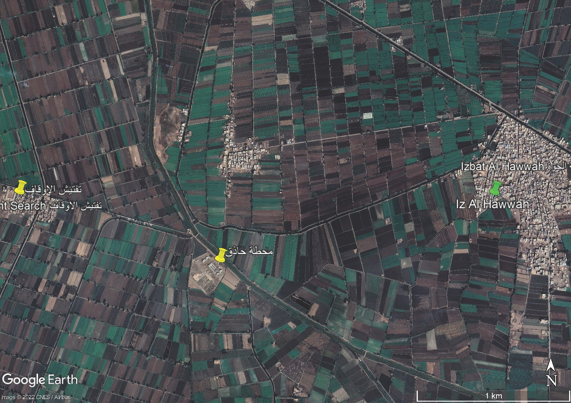
Figure 8 Location of Hazeq WWTP
The location of Biyala WWTP is given below
31° 9'6.14"N, 31°14'25.78"E and indicated in Figure 5

The location of Ibshan WWTP is given below
31° 9'9.62"N, 31° 9'34.93"E and indicated in Figure 6

The location of Al Al-Nasryyah Cluster is indicated in Figure 1

The location of Kafr Al Jaraydah Cluster is indicated in Figure 7

Project Coordination
The Contract for the assignment will be signed by the Kafr ElSheikh Water and Sanitation Company and the Consultant. However, the Consultant will also be required to coordinate with the PIC and HCWW PMU to enable the PIC and HCWW to perform their duties as described in this Terms of Reference.

Services and Facilities to be Provided by Kafr ElSheikh WSC

The Kafr ElSheikh will provide the following facilities and services to the consultant as outlined below:
- At the commencement of the assignment the Kafr ElSheikh WSC will make available to the Consultant all available data, information, and reports deemed necessary for the assignment. The Consultant shall treat these documents with care and confidentiality and return them in good order to the Kafr ElSheikh WSC at the end of the assignment.
- Liaison and assistance for any information or documents required from other Government Agencies and which the Kafr ElSheikh’s Representative considers essential for the proper conduct and execution of this assignment.
- Customs and tax exemptions details shall be stipulated in the Special Conditions of Contract

Services and Facilities to be Provided by the Consultant
The Kafr ElSheikh WSC will not provide the consultant with any office supplies or any other equipment and the consultant should estimate the cost of renting and operating the regional office at a location close to the headquarters of the Kafr ElSheikh Company for Water and Wastewater with an area of 200 m² (for the full duration of services) so that the project's work and tasks can be managed at various implementation sites, and the office must be equipped with equipment, facilities and furnishings (furniture, computers, printer and scanner, data show, Telephone, fax, camera, projector and internet service etc.) and equipped with the appropriate means of subsistence and hospitality to work on the project. The office shall be furnished with a meeting room suitable to accommodate at least twenty (20) persons.
The Consultant is expected to provide the following facilities:
- Home office space at least 200 m2 and equipped with all equipment and facilities, with a meeting room able to have not less 20 persons.
- (6) Laptops and IT equipment for the Consultant team,
- 6 new sedan vehicles model 2021 or later 1600 CC for the transportation of the Consultant team.
- Stationary
- Survey equipment
- Any other facilities that might be needed to carry out the assignment.

The ownership of all the equipment shall not be transferred to Kafr ElSheikh Company for Water and Wastewater at the end of the project.

During the implementation phase of the project the Contractor will supply suitable office accommodation at each construction location for the Engineer and staff. This accommodation will be supplied with suitable furniture and services for the day-to-day operation of the Engineer’s staff. The Consultant will be required to provide all IT infrastructure to perform their duties.

The flow from two villages (Al Himmah and Iz. Badawi) shall be directed to Nasryyah WWTP. The design of the sewerage system of the two additional villages (Al Himmah and Iz. Badawi) and their force main to the Nasryyah WWTP are outside the consultant scope of works.
Population is not including satellites
Population is not including satellites
A copy from the PPM will be provided to the Consultant upon contract signature.
A copy from the PPM will be provided to the Consultant upon contract signature.
A copy from the PPM will be provided to the Consultant upon contract signature.
https://www.eib.org/en/publications/environmental-and-social-principles-and-standards.htm
https://www.eib.org/attachments/publications/eib_environmental_and_social_standards_en.pdf
In case of any differences in the selection criteria stated on the RFP and TOR, the one stated in RFP will prevail.
The team leader shall be common expert for all project tasks
The deputy team leader shall be common for all project tasks
During the defects liability period, only the operation and maintenance specialist shall work on a part time basis.
During the defects liability period, only the operation and maintenance specialist shall work on a part time basis.
During the defects liability period, only the operation and maintenance specialist shall work on a part time basis.
During the defects’ liability period, only the operation and maintenance specialist shall work on a part time basis.

